**Saint Patrick’s Day**

**5:30PM, March 17, 2023**

Saint Patrick was a fifth-century Romano-British Christian missionary and bishop in Ireland.Known as the “Apostle of Ireland,” he is the primary [patron saint](https://en.wikipedia.org/wiki/Patron_saint) of [Ireland](https://en.wikipedia.org/wiki/Republic_of_Ireland), the other patron saints being Brigit of Kildare and [Columba](https://en.wikipedia.org/wiki/Columba). The dates of Patrick’s life cannot be fixed with certainty, but there is general agreement that he was active as a missionary in Ireland during the fifth century. According to tradition dating back to the early Middle Ages, Patrick served as the first bishop of [Armagh](https://en.wikipedia.org/wiki/Armagh) and [Primate of Ireland](https://en.wikipedia.org/wiki/Primacy_of_Ireland), and credits him with bringing Christianity to Ireland, converting a [pagan society](https://en.wikipedia.org/wiki/Celtic_polytheism). He has been generally so regarded ever since, despite evidence of some earlier Christian presence in Ireland. According to the autobiographical *Confessio* of Patrick, when he was about sixteen, he was captured by Irish pirates from his home in Britain and taken as a [slave](https://en.wikipedia.org/wiki/Slavery_in_medieval_Europe) to Ireland, looking after animals; he lived there for six years before escaping and returning to his family. After becoming a cleric, he returned to northern and western Ireland. In later life, he served as a bishop, but little is known about the places where he worked. By the seventh century, he had already come to be revered as the patron saint of Ireland. [His feast day](https://en.wikipedia.org/wiki/Saint_Patrick%27s_Day) is observed on 17 March, the supposed date of his death. It is celebrated inside and outside Ireland as a religious and cultural holiday.

**Welcome to Christ Church**

The Parish of Christ the Redeemer (known as Christ Church) is the Episcopal Church in Pelham, New York. The Episcopal Church is part of the Anglican Communion which is made up of 85 million people in over 165 countries and is the third largest Christian denomination in the world.

Christ Church was founded in 1843 and is the first house of worship in Pelham. This building was consecrated on September 15, 1843, the original church building was expanded in 1910, and the sanctuary was reconstructed in 1968 to allow for the current, more intimate worship space. Our congregation draws primarily from Pelham, New Rochelle, Mount Vernon, and the Bronx, and includes people from diverse denominational and cultural backgrounds. Whether you are new to Christ Church or a long-time member, you are invited to pray in our sacred spaces, join in our services of worship, and take an active role in the life and leadership of the parish. We give thanks and praise to God for your presence with us this morning!

Children of all ages are always welcome in church. A great place for children to see, hear and participate is in the front pews of the church. Also, childcare is available in the Nursery every Sunday during the 10:00 AM Holy Eucharist. Sunday School is offered during the academic year from September until June. Sunday School begins at 10:00 AM each Sunday. After the children’s service and Sunday School activities, the children join the rest of the congregation for the Holy Communion. If you believe God may be calling you to a new relationship with him through Jesus Christ, we want to be of help. Whether you want to receive the Sacrament of Holy Baptism, receive the laying on of hands by the bishop in the sacramental rite of Confirmation, or transfer your membership from another church denomination, joining Christ Church is easy, just speak to Father Matthew Mead, Deacon Chisara Alimole, or our Administrator, Ms. Marie Main.

*The Curly Willow Branches are given in Thanksgiving for our Rector, Fr. Matthew Hoxsie Mead.*



**Organ Prelude**

Prelude, Op. 101, No. 6 *(Founded on an old Irish church melody: “St. Columba”) by Charles Villiers Stanford (1852-1924).*

**Processional Hymn (279)**

*All stand and sing the hymn as the acolytes and clergy enter.*

Words: Richard Mant (1776-1848), alt.

Music:  *St. George*, Henry John Gauntlett (1805-1876)

**Collect for Purity**

*All remain standing.*

*Celebrant* Almighty God, to you all hearts are open, all desires known, and from you no secrets are hid: Cleanse the thoughts of our hearts by the inspiration of your Holy Spirit, that we may perfectly love you, and worthily magnify your holy Name; through Christ our Lord.

***All*** **Amen.**

**Gloria in excelsis (#S 280)**

*All remain standing and sing “Glory to God in the highest”.*

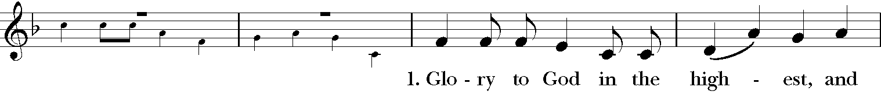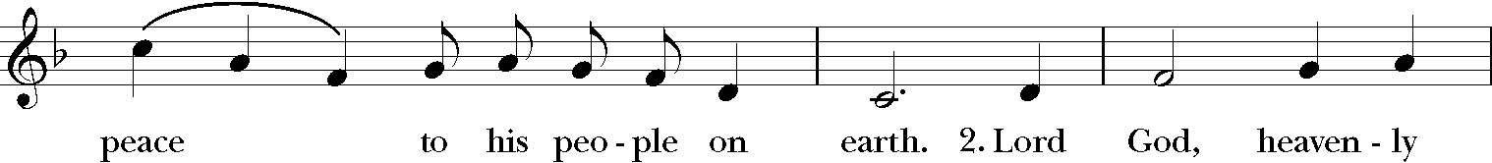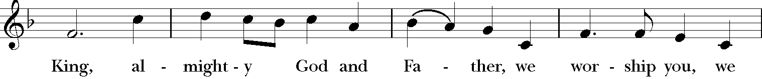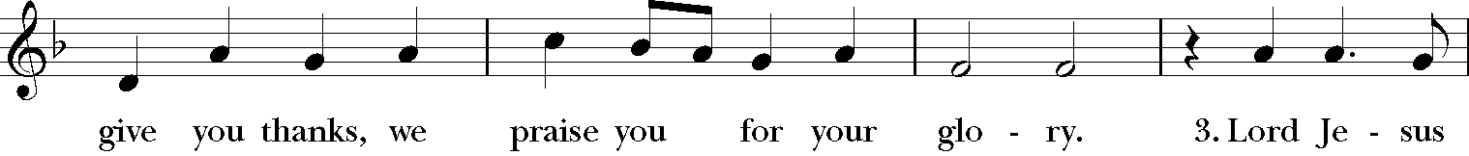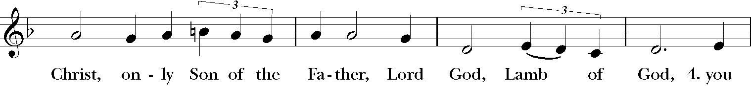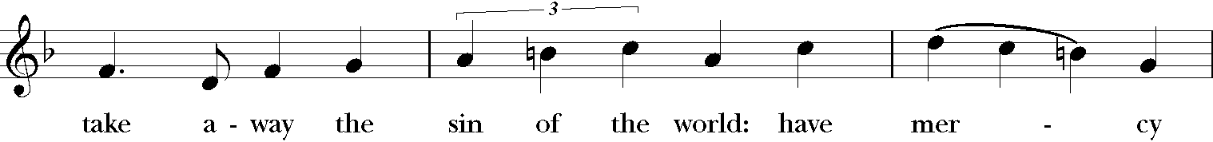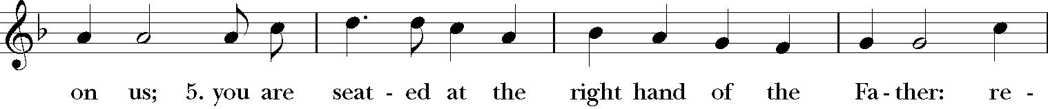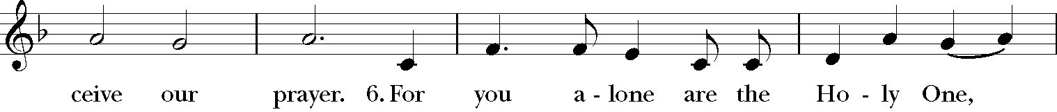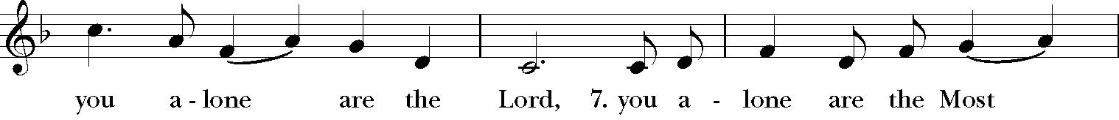

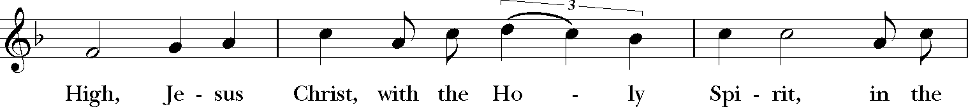

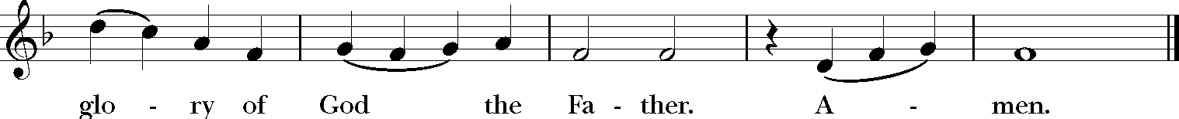

**Music:** Robert J. Powell (*b.* 1932), rev.

**Collect of the Day**

*All remain standing.*

*Celebrant* The Lord be with you.

***People* And also with you.**

*Celebrant* Let us pray.

Almighty God, in your providence you chose your servant Patrick to be the apostle to the Irish people, to bring those who were wandering in darkness and error to the true light and knowledge of you: Grant us so to walk in that way that we may come at last to the light of everlasting life; through Jesus Christ our Lord, who lives and reigns with you and the Holy Spirit, one God, for ever and ever.

***People*****Amen.**

**The Epistle: 1 Thessalonians 2:1–8**

*All remain seated as the lesson is read.*

*Reader* A Reading from the Letter of Paul to the Thessalonians.

You yourselves know, brothers and sisters, that our coming to you was not in vain, but though we had already suffered and been shamefully mistreated at Philippi, as you know, we had courage in our God to declare to you the gospel of God in spite of great opposition. For our appeal does not spring from deceit or impure motives or trickery, but just as we have been approved by God to be entrusted with the message of the gospel, even so we speak, not to please mortals, but to please God who tests our hearts. As you know and as God is our witness, we never came with words of flattery or with a pretext for greed; nor did we seek praise from mortals, whether from you or from others, though we might have made demands as apostles of Christ. But we were gentle among you, like a nurse tenderly caring for her own children. So deeply do we care for you that we are determined to share with you not only the gospel of God but also our own selves, because you have become very dear to us.

The Word of the Lord.

***People* Thanks be to God.**

**Sequence Hymn (#645)**

*All stand and sing the hymn.*

Words: Henry Williams Baker (1821-1877); paraphrase of Psalm 23  
Music: *St. Columba*, Irish melody; harmonized *Hymnal 1982*

**The Holy Gospel:** Matthew 28:16–20

*All remain standing for the Gospel.*

*Deacon* X The Holy Gospel of our Lord Jesus Christ according to Matthew.

***People*** **Glory to you, Lord Christ.**

*Deacon* The eleven disciples went to Galilee, to the mountain to which Jesus had directed them. When they saw him, they worshiped him; but some doubted. And Jesus came and said to them, “All authority in heaven and on earth has been given to me. Go therefore and make disciples of all nations, baptizing them in the name of the Father and of the Son and of the Holy Spirit, and teaching them to obey everything that I have commanded you. And remember, I am with you always, to the end of the age.”

The Gospel of the Lord.

***People* Praise to you, Lord Christ.**

**Sermon**

*All are seated for the sermon by the Rector, Father Matthew Hoxsie Mead*

**The Prayers of the People (Form IV)**

*Reader*  Let us pray for the Church and for the world.

Grant, Almighty God, that all who confess your Name may be united in your truth, live together in your love, and reveal your glory in the world.Lord, in your mercy,

***People***   **Hear our prayer.**

*Reader* Guide the people of this land, and of all the nations, in the

ways of justice and peace; that we may honor one another

and serve the common good. Lord, in your mercy,

***People***   **Hear our prayer.**

*Reader* Give us all a reverence for the earth as your own creation, that we may use its resources rightly in the service of others and to your honor and glory. Lord, in your mercy,

***People***   **Hear our prayer.**

*Reader* Bless all whose lives are closely linked with ours, [especially *(add Birthday List here)*]and grant that we may serve Christ in them and love one another as he loves us. Lord, in your mercy,

***People***   **Hear our prayer***.*

*Reader* Comfort and heal all those who suffer in body, mind, or spirit;

[*especially – (add Prayer List/Armed Services)*]give them courage and hope in their troubles and bring them the joy of your salvation. Lord, in your mercy,

***People***   **Hear our prayer.**

*Reader* We commend to your mercy all who have died, [*especially – (add Departed List)*] that your will for them may be fulfilled; and we pray that we may share with all your saints in your eternal kingdom. Lord, in your mercy,

***People***   **Hear our prayer.**

*Silence is kept. Then the Celebrant adds a concluding prayer. All respond,* **Amen**

**The Peace**

*All remain standing.*

*Celebrant*  The Peace of the Lord be always with you.

*People* **And also with you.**

*Then the ministers and people greet one another in the name of the Lord.*

**Welcome & Offertory Sentence**

*All are seated for a brief welcome and announcements from Father Matthew Mead. The announcements conclude with the following or some other offertory sentence.* I appeal to you, brethren, by the mercies of God, to present yourselves as a living sacrifice, holy and acceptable to God, which is your spiritual worship

**Offertory Hymn (#488)**

*All stand and sing the hymn as an offering is brought to the altar and blessed.*

**Words:** Irish, ca. 700; versified Mary Elizabeth Byrne (1880-1931); tr. Eleanor H. Hull (1860-1935), alt.

**Music:***Slane*, Irish ballad melody; adapt. *The Church Hymnary*, 1927; harm. David Evans (1874-1948) and Jeffrey Hoffman (*b.* 1970)

**The Great Thanksgiving**

*All remain standing.*

*Celebrant* It is right, and a good and joyful thing, always and everywhere to give thanks to you, Father Almighty, Creator of heaven and earth; For in the multitude of your saints you have surrounded us with a great cloud of witnesses, that we might rejoice in their fellowship, and run with endurance the race that is set before us; and, together with them, receive the crown of glory that never fades away. Therefore we praise you, joining our voices with Angels and Archangels and with all the company of heaven, who for ever sing this hymn to proclaim the glory of your Name:

**Sanctus et Benedictus**

*All remain standing and sing “Holy, holy, holy” (#S 129)*

C:\Users\Matthew\AppData\Local\Microsoft\Windows\Temporary Internet Files\Content.Word\S129a.tif

C:\Users\Matthew\AppData\Local\Microsoft\Windows\Temporary Internet Files\Content.Word\S129a.tif C:\Users\Matthew\AppData\Local\Microsoft\Windows\Temporary Internet Files\Content.Word\S129a.tif C:\Users\Matthew\AppData\Local\Microsoft\Windows\Temporary Internet Files\Content.Word\S129a.tif

**Music:** Robert J. Powell (*b.* 1932)

*The people stand or kneel.*

*Celebrant*  Holy and gracious Father: In your infinite love you made us for yourself; and, when we had fallen into sin and become subject to evil and death, you, in your mercy, sent Jesus Christ, your only and eternal Son, to share our human nature, to live and die as one of us, to reconcile us to you, the God and Father of all. He stretched out his arms upon the cross, and offered himself in obedience to your will, a perfect sacrifice for the whole world.

On the night he was handed over to suffering and death, our Lord Jesus Christ took bread; and when he had given thanks to you, he broke it, and gave it to his disciples, and said, “Take, eat: This is my Body, which is given for you. Do this for the remembrance of me.”

After supper he took the cup of wine; and when he had given thanks, he gave it to them, and said, “Drink this, all of you: This is my Blood of the new Covenant, which is shed for you and for many for the forgiveness of sins. Whenever you drink it, do this for the remembrance of me.”

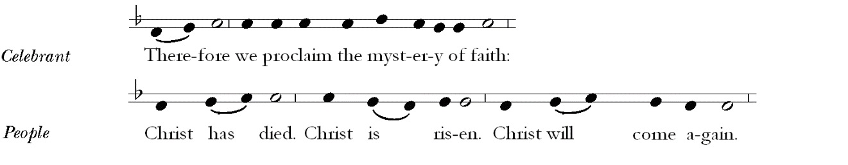

*Celebrant*  We celebrate the memorial of our redemption, O Father, in this sacrifice of praise and thanksgiving. Recalling his death, resurrection, and ascension, we offer you these gifts. Sanctify them by your Holy Spirit to be for your people the Body and Blood of your Son, the holy food and drink of new and unending life in him.

Sanctify X us also that we may faithfully receive this holy Sacrament, and serve you in unity, constancy, and peace; and at the last day bring us with all your saints into the joy of your eternal kingdom.

All this we ask through your Son Jesus Christ. By X him, and with him, and in him, in the unity of the Holy Spirit all honor and glory is yours, Almighty Father,



*Celebrant* And now, as our Savior Christ hath taught us, we are bold to say,

***All*** **Our Father, who art in heaven,**

**hallowed be thy Name,**

**thy kingdom come,**

**thy will be done,**

**on earth as it is in heaven.**

**Give us this day our daily bread.**

**And forgive us our trespasses,**

**as we forgive those who trespass against us.**

**And lead us not into temptation,**

**but deliver us from evil.**

**For thine is the kingdom, and the power, and the glory,**

**for ever and ever. Amen.**

**The Breaking of the Bread**

*The Celebrant breaks the consecrated bread. A period of silence is observed.*

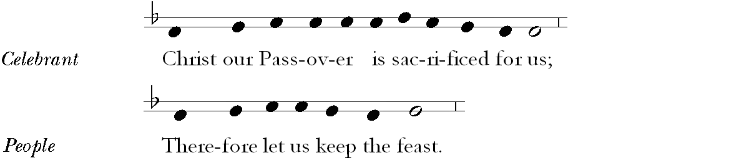

**Agnus Dei**

*All remain standing and sing “Lamb of God” (Hymn #S 163)*

C:\Users\Matthew\AppData\Local\Microsoft\Windows\Temporary Internet Files\Content.Word\S163a.tifC:\Users\Matthew\AppData\Local\Microsoft\Windows\Temporary Internet Files\Content.Word\S163a.tifC:\Users\Matthew\AppData\Local\Microsoft\Windows\Temporary Internet Files\Content.Word\S163a.tifC:\Users\Matthew\AppData\Local\Microsoft\Windows\Temporary Internet Files\Content.Word\S163a.tif

Music: Robert J. Powell (*b.* 1932)

**Invitation to Holy Communion**

*The Celebrant invites the people to receive the Holy Communion saying the following or some other invitation.*

*Celebrant* The Gifts of God for the people of God. Take them in remembrance that Christ died for you, and feed on him in your hearts by faith with thanksgiving.

*All baptized persons, including children, are full members of the Body of Christ and are invited to participate in every aspect of the service and receive the Holy Communion. Members of other Christian churches who are baptized are also invited to receive the Body and Blood of Christ. Persons who do not wish to receive Holy Communion are also invited to come forward with everyone else to receive a blessing (cross your arms over your chest to indicate that you want a blessing and not Holy Communion).*

**Communion Hymn (508)**

Words: Edwin Hatch (1835-1889), alt.

Music: *Nova Vita,* Lister R. Peace (1885-1969)

**Postcommunion Prayer**

*After Communion all kneel and join in the final prayer.*

*Celebrant* Let us pray.

***All*****Eternal God, heavenly Father,**

**you have graciously accepted us as living members**

**of your Son our Savior Jesus Christ,**

**and you have fed us with spiritual food**

**in the Sacrament of his Body and Blood.**

**Send us now into the world in peace,**

**and grant us strength and courage**

**to love and serve you**

**with gladness and singleness of heart;**

**through Christ our Lord. Amen.**

**Solemn Prayer over the People**

*All remain kneeling.*

*Celebrant* Let us bow our heads and pray for God’s blessing.

*Silence is observed.*

*Celebrant* May the road rise up to meet you. May the wind be always at your back. May the sun shine warm upon your face; the rains fall soft upon your fields and until we meet again, may God hold you in the palm of His hand. And the blessing of God Almighty, the Father, the Son, and the Holy Spirit, be upon you and remain with you for ever.

***People*** **Amen.**

**Processional Hymn (# 370)**

*All stand and sing the hymn as the ministers process to the back of the church.*

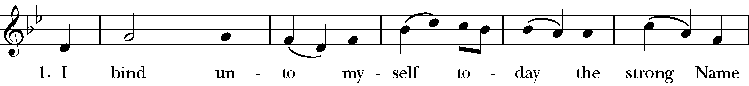

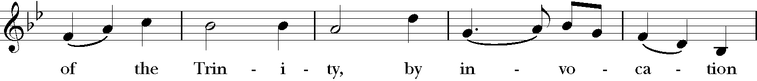

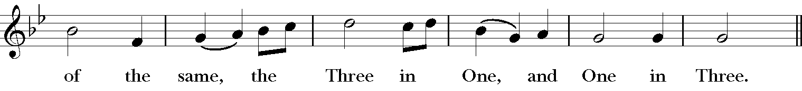

(Continued on the next page)

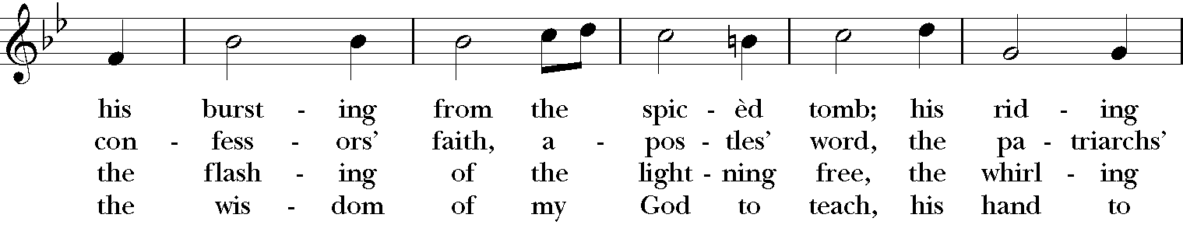

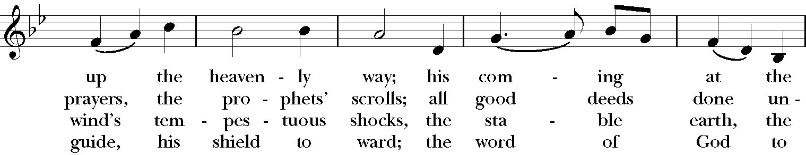

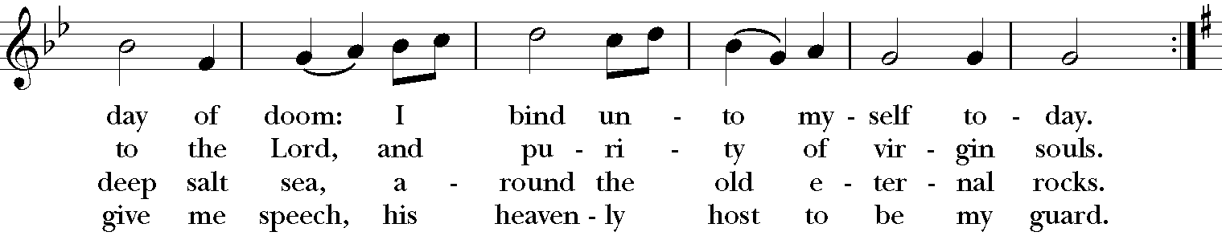

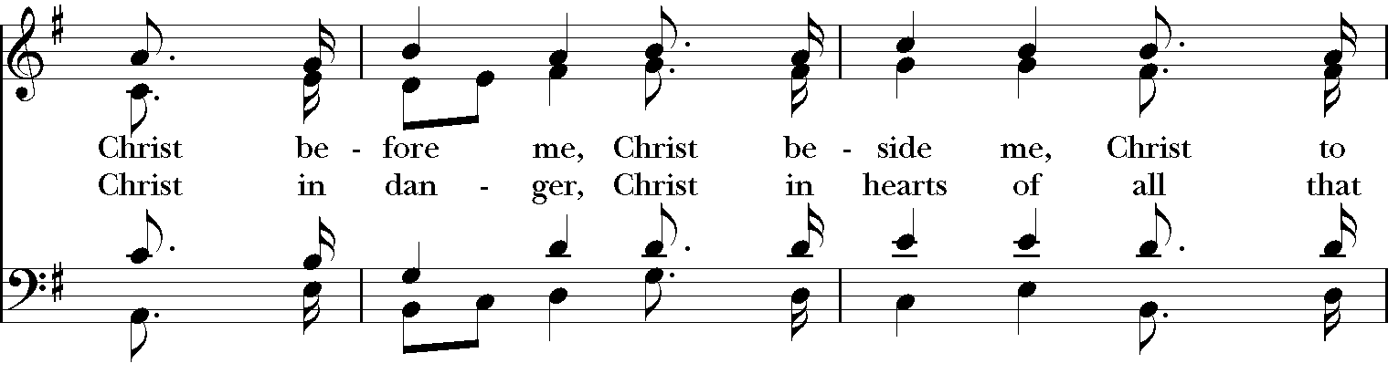

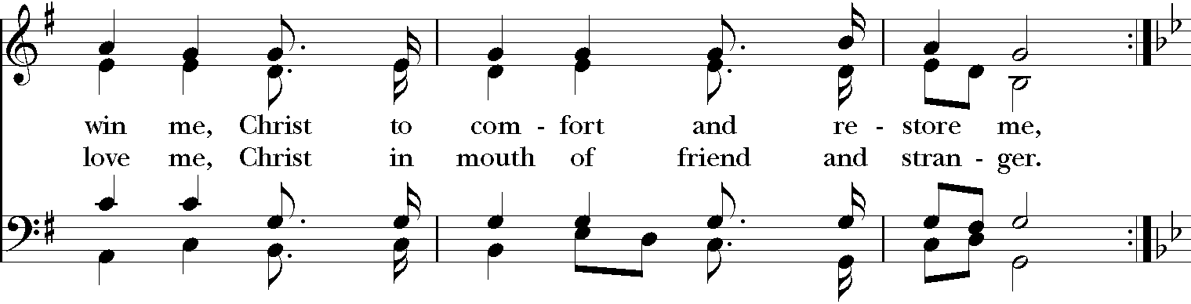

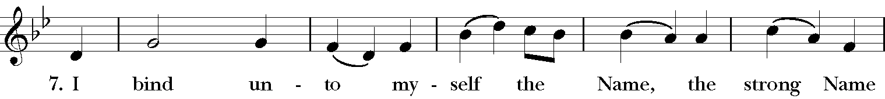

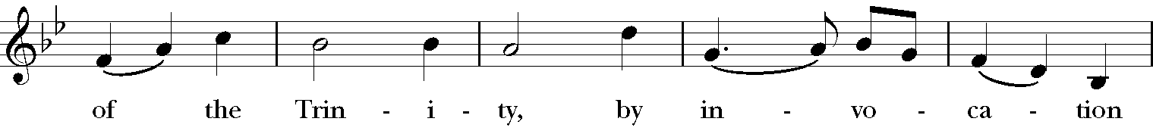

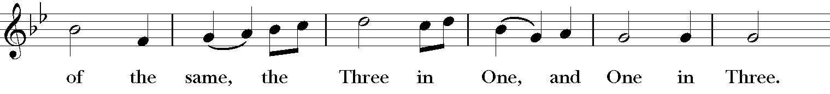

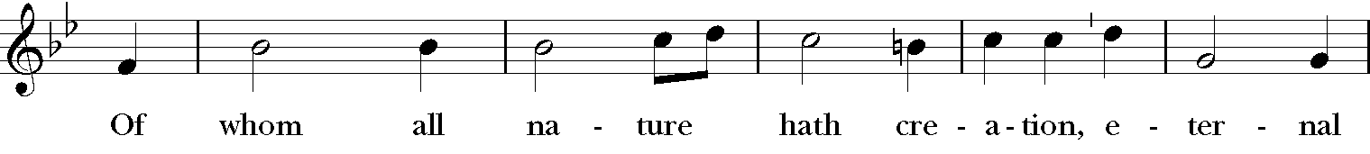

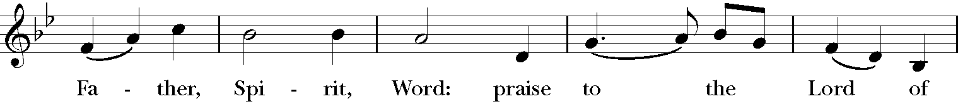

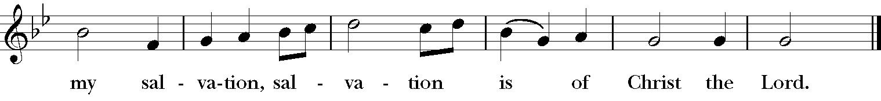

**Words:**  Att. Patrick (372-466); tr. Cecil Frances Alexander (1818-1895)  
**Music:** *St. Patrick’s Breastplate,* Irish melody; adapt. Charles Villiers Stanford (1852-1924) and Jeffrey Hoffman (*b.* 1970);

St. 6, *Deirdre*, Irish melody; harm. Ralph Vaughan Williams (1872-1958)

**dismissal**

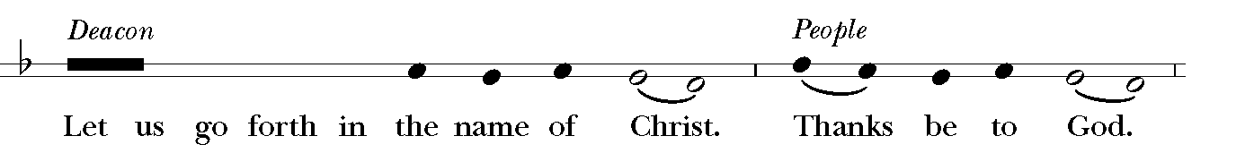

**Organ Voluntary**

***If you are staying in your pew for the Voluntary, please be courteous to those who are listening to the music by remaining quiet.***

Homage to Fritz Keisler (“Londonderry Air”) *by Robert Hebble (1934-2020).*

***Scan this QR Code to join our Email List and catch up on everything that’s happening at Christ Church***

***Scan this QR Code to donate online.***

Please join us in the Parish Hall for Saint Patrick’s Day Potluck

&

“Meet Saint Patrick & his Saintly Friends”

**(*A dinner-time interactive program offered by Michael Moynihan and Father Matt)***

Christ church

**Episcopal/Anglican**

**Clergy & Staff**

The Reverend Matthew Hoxsie Mead*, Rector*

The Reverend Deacon Chisara Alimole

Mr. Jeffrey Hoffman*, Organist and Choirmaster*

Ms. Marie Main*, Parish Administrator*

Mr. Walter Roberts*, Verger and Sexton*

Mr. Ed Blue*, Sexton*

**Wardens & Vestry**

The Reverend Matthew Hoxsie Mead*, Rector*

Mr. Jeff Bodenmann, *Senior Warden*

Ms. Etta Gumbs, *Junior Warden*

Ms. Allison Bodenmann*, Treasurer*

Mr. John Fox, *Assistant Treasurer*

Ms. Jean Gruener, *Clerk*

Ms. Jennifer Hawks Bland Mr. John Fox

Mr. J.D. Calder Mr. Jack Kraft

Mr. Andy Des Rault Mr. Robert Landis

Mr. Stephen Dolan Ms. Courtney McGrory

Ms. Barbara Zambelli

***The Holy Eucharist is celebrated on Sundays at 8 and 10 a.m.***

***Morning Prayer*** *is read on, Tuesdays at 10:30 a.m. on Zoom*

† A Parish of the Diocese of New York †

**Christ Church**  
The Parish of Christ the Redeemer

1415 Pelhamdale Avenue, Pelham, New York 10803

914.738.5515

914.712.0526, *fax*

www.christchurchpelham.org

***Christ Church Pelham is a Christian community in the Episcopal tradition.***

***As members of the Body of Christ, we are dedicated to spiritual growth***

***and committed to serving God through worship and***

***service to our community and the world.***