**The Baptism of our Lord Jesus Christ**

**10:00 AM, January 8, 2023**

This is the First Sunday after the Epiphany, traditionally observed as the Feast of the Baptism of Our Lord Jesus Christ. This period in the Church year is known as the “Epiphany Season” or “Ordinary Time.” The term “ordinary” refers to how the New Testament passages are generally read in order or in sequence, as opposed to being arranged by specific theme as in other seasons. During this season the Gospel passages focus on the beginning of Jesus’ ministry and how he is revealed to the world as the Christ. In Year A (the first in a three-year cycle: A, B & C) most of the Gospel passages are from the Gospel according to Matthew. The Old Testament Lesson and the Psalm are chosen because they relate to the words and message of Jesus. The New Testament Lesson is independent of these readings and is almost always taken from one of the Letters in the New Testament that reflects the common life and mission of the first Christian community.

**Welcome to Christ Church**

The Parish of Christ the Redeemer (known as Christ Church) is the Episcopal Church in Pelham, New York. The Episcopal Church is part of the Anglican Communion which is made up of 85 million people in over 165 countries and is the third largest Christian denomination in the world.

Christ Church was founded in 1843 and is the first house of worship in Pelham. This building was consecrated on September 15, 1843, the original church building was expanded in 1910, and the sanctuary was reconstructed in 1968 to allow for the current, more intimate worship space. Our congregation draws primarily from Pelham, New Rochelle, Mount Vernon, and the Bronx, and includes people from diverse denominational and cultural backgrounds. Whether you are new to Christ Church or a long-time member, you are invited to pray in our sacred spaces, join in our services of worship, and take an active role in the life and leadership of the parish. We give thanks and praise to God for your presence with us this morning!

Children of all ages are always welcome in church. A great place for children to see, hear and participate is in the front pews of the church. Also, childcare is available in the Nursery every Sunday during the 10:00 AM Holy Eucharist. Sunday School is offered during the academic year from September until June. Sunday School begins at 10:00 AM each Sunday. After the children’s service and Sunday School activities, the children join the rest of the congregation for the Holy Communion.

If you believe God may be calling you to a new relationship with him through Jesus Christ we want to be of help. Whether you want to receive the Sacrament of Holy Baptism, receive the laying on of hands by the bishop in the sacramental rite of Confirmation, or transfer your membership from another church or

denomination, joining Christ Church is easy, just speak to Father Matthew Mead, Deacon Chisara Alimole, or our Administrator, Ms. Marie Main.

*The Trees on the Altar are given to the Glory of God*



**Organ Prelude**

Chorale-Prelude on “Christ, unser Herr, zum Jordan kam” (“Christ, our Lord, went to Jordan’s stream”), BWV 685, *by Johann Sebastian Bach (1685-1750).*

Chorale-Prelude on “Gott des Himmels und der Erden” (“God who madest Earth and Heaven”), *by Johann Gottfried Walther (1684-1748).*

**Entrance Hymn (# 448)**

*All stand and sing the hymn as the ministers enter.*

Words: Latin, 15th cent.; tr. Benjamin Webb (1819-1885), alt.  
Music: *Deus tuorum militum*, from *Antiphoner*, 1753; adapt. *The English Hymnal*, 1906, alt.; harm. after Basil Harwood (1859-1949)

**Opening Acclamation & Collect for Purity**

*All remain standing.*

*Celebrant* X Blessed be God: Father, Son and Holy Spirit.

***People* And blessed be God’s kingdom, now and for ever. Amen.**

*Celebrant* Almighty God, to you all hearts are open, all desires known, and from you no secrets are hid: Cleanse the thoughts of our hearts by the inspiration of your Holy Spirit, that we may perfectly love you, and worthily magnify your holy Name; through Christ our Lord.

***All*** **Amen.**

**Hymn of Praise (#421), Gloria in Excelsis Deo**

*All remain standing and sing the Song of Praise.*

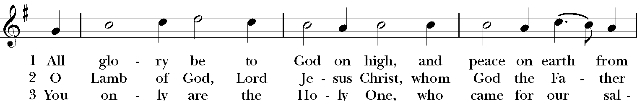

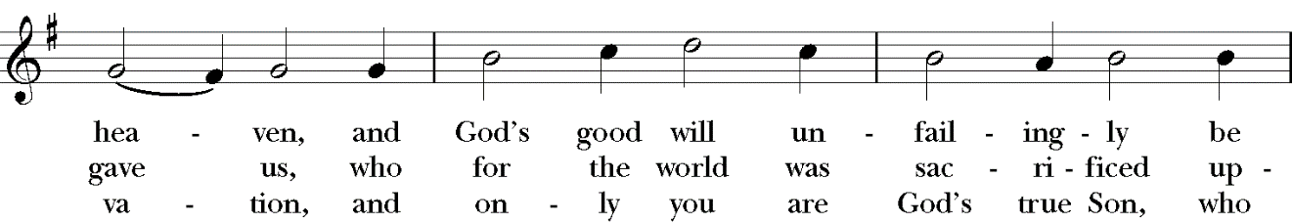

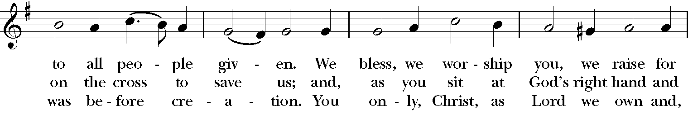

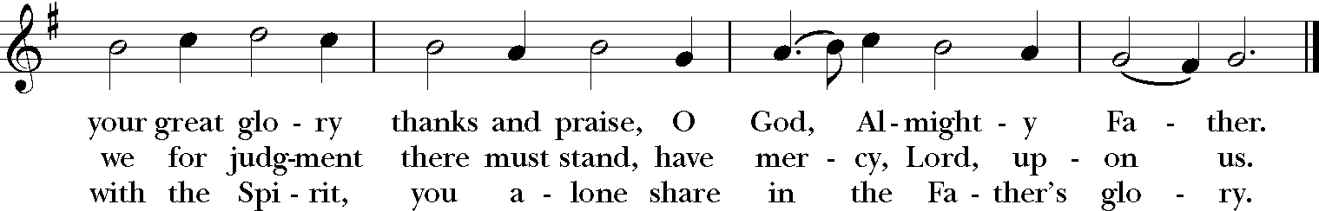

Words: Nikolaus Decius (1490?-1541); tr. F. Bland Tucker (1895-1984), rev.; para. of *Gloria in excelsis*

Music: Allein Gott in der Höh, melody att. Nikolaus Decius (1490?-1541); harm. Hieronymous Praetorius (1560?-1629)

**Collect of the Day**

*All remain standing.*

*Celebrant* The Lord be with you.

***People* And also with you.**

*Celebrant* Let us pray.

Father in heaven, who at the baptism of Jesus in the River Jordan proclaimed him your beloved Son and anointed him with the Holy Spirit: Grant that all who are baptized into his Name may keep the covenant they have made, and boldly confess him as Lord and Savior; who with you and the Holy Spirit lives and reigns, one God, in glory everlasting.

***All*****Amen.**

**The First Lesson: Isaiah 42:1-9**

*All are seated as the lesson is read.*

*Reader* A reading from the Book of Isaiah.

Here is my servant, whom I uphold, my chosen, in whom my soul delights; I have put my spirit upon him; he will bring forth justice to the nations. He will not cry or lift up his voice or make it heard in the street; a bruised reed he will not break, and a dimly burning wick he will not quench; he will faithfully bring forth justice. He will not grow faint or be crushed until he has established justice in the earth; and the coastlands wait for his teaching. Thus says God, the Lord, who created the heavens and stretched them out, who spread out the earth and what comes from it, who gives breath to the people upon it and spirit to those who walk in it: I am the Lord, I have called you in righteousness, I have taken you by the hand and kept you; I have given you as a covenant to the people, a light to the nations, to open the eyes that are blind, to bring out the prisoners from the dungeon, from the prison those who sit in darkness. I am the Lord, that is my name; my glory I give to no other, nor my praise to idols. See, the former things have come to pass, and new things I now declare; before they spring forth, I tell you of them.

The Word of the Lord.

***People*****Thanks be to God.**

**The Psalm**

**Psalm 29,** *Afferte Domino*

*All remain seated as the choir sings the Psalm to an Anglican chant by Percy Buck (1871-1947).*

1 Ascribe to the Lord, you gods, *

ascribe to the Lord glory and strength.

2 Ascribe to the Lord the glory due his Name; *

worship the Lord in the beauty of holiness.

3 The voice of the Lord is upon the waters;

the God of glory thunders; *

the Lord is upon the mighty waters.

4 The voice of the Lord is a powerful voice; *

the voice of the Lord is a voice of splendor.

5 The voice of the Lord breaks the cedar trees; *

the Lord breaks the cedars of Lebanon;

6 He makes Lebanon skip like a calf, *

and Mount Hermon like a young wild ox.

7 The voice of the Lord splits the flames of fire;

the voice of the Lord shakes the wilderness; *

the Lord shakes the wilderness of Kadesh.

8 The voice of the Lord makes the oak trees writhe *

and strips the forests bare.

9 And in the temple of the Lord *

all are crying, “Glory!”

10 The Lord sits enthroned above the flood; *

the Lord sits enthroned as King for evermore.

11 The Lord shall give strength to his people; *

the Lord shall give his people the blessing of peace.

**The Second Lesson:** Acts 10:34-43

*All remain seated as the lesson is read.*

*Reader* A Reading from the Acts of the Apostles.

Peter began to speak to them: “I truly understand that God shows no partiality, but in every nation anyone who fears him and does what is right is acceptable to him. You know the message he sent to the people of Israel, preaching peace by Jesus Christ – he is Lord of all. That message spread throughout Judea, beginning in Galilee after the baptism that John announced: how God anointed Jesus of Nazareth with the Holy Spirit and with power; how he went about doing good and healing all who were oppressed by the devil, for God was with him. We are witnesses to all that he did both in Judea and in Jerusalem. They put him to death by hanging him on a tree; but God raised him on the third day and allowed him to appear, not to all the people but to us who were chosen by God as witnesses, and who ate and drank with him after he rose from the dead. He commanded us to preach to the people and to testify that he is the one ordained by God as judge of the living and the dead. All the prophets testify about him that everyone who believes in him receives forgiveness of sins through his name.”

The Word of the Lord

***People*****Thanks be to God.**

**Sequence Hymn (# 121)**

*All stand and sing the hymn.*

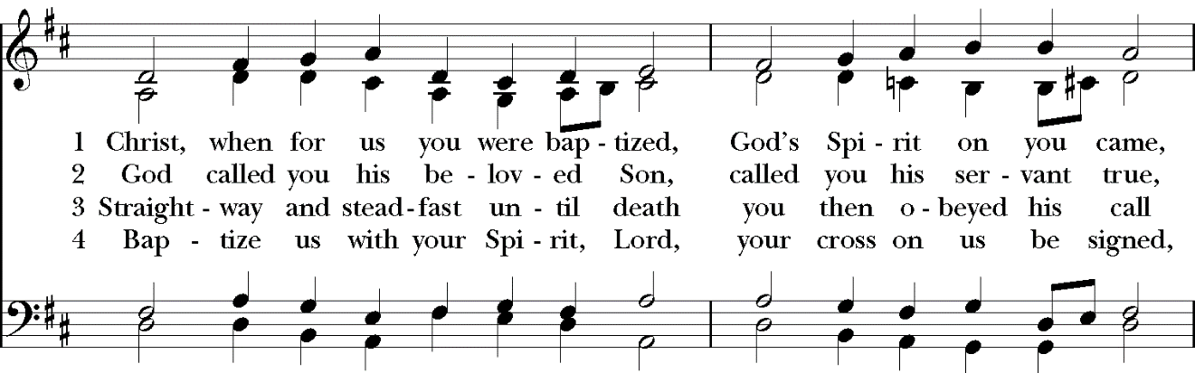

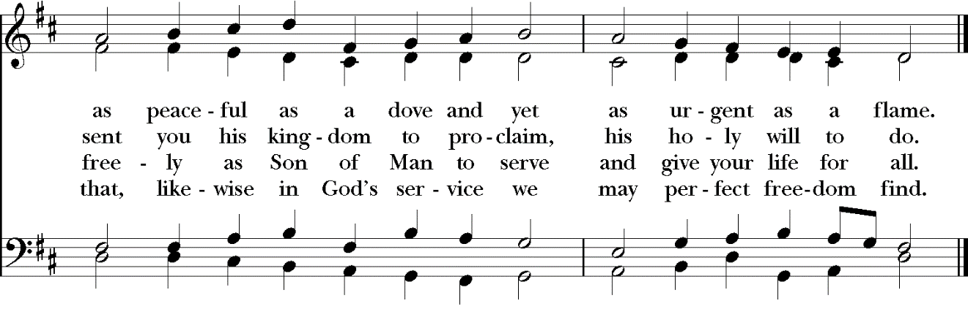

Words: F. Bland Tucker (1895-1984), rev.;

Music: *Caithness*, melody from *The Psalmes of David in Prose and Meeter, 1635*; harm. *The English Hymnal.*

**The Holy Gospel:** Matthew 3:13-17

*All remain standing for the Gospel.*

*Deacon* X The Holy Gospel of our Lord Jesus Christ according to Matthew.

***People*** **Glory to you, Lord Christ.**

*Deacon* Jesus came from Galilee to John at the Jordan, to be baptized by him. John would have prevented him, saying, “I need to be baptized by you, and do you come to me?” But Jesus answered him, “Let it be so now; for it is proper for us in this way to fulfill all righteousness.” Then he consented. And when Jesus had been baptized, just as he came up from the water, suddenly the heavens were opened to him and he saw the Spirit of God descending like a dove and alighting on him. And a voice from heaven said, “This is my Son, the Beloved, with whom I am well pleased.”

The Gospel of the Lord.

***People*** **Praise to you, Lord Christ**

**The** **Sermon**

*All are seated for the sermon by the Rector, Father Matthew Hoxsie Mead.*

**Nicene Creed**

*All stand and join in saying the Nicene Creed.*

*Celebrant* We believe in one God,

*All*  **the Father, the Almighty,**

**maker of heaven and earth,**

**of all that is, seen and unseen.**

**We believe in one Lord, Jesus Christ,**

**the only Son of God,**

**eternally begotten of the Father,**

**God from God, Light from Light,**

**true God from true God,**

**begotten, not made,**

**of one Being with the Father.**

**Through him all things were made.**

**For us and for our salvation**

**he came down from heaven:**

**by the power of the Holy Spirit**

**he became incarnate from the Virgin Mary,**

**and was made man.**

**For our sake he was crucified under Pontius Pilate;**

**he suffered death and was buried.**

**On the third day he rose again**

**in accordance with the Scriptures;**

**he ascended into heaven**

**and is seated at the right hand of the Father.**

**He will come again in glory to judge the living and the dead,**

**and his kingdom will have no end.**

**We believe in the Holy Spirit, the Lord, the giver of life,**

**who proceeds from the Father and the Son.**

**With the Father and the Son he is worshiped and glorified.**

**He has spoken through the Prophets.**

**We believe in one holy catholic and apostolic Church.**

**We acknowledge one baptism for the forgiveness of sins.**

**We look for the resurrection of the dead,**

**and the life of the world to come. Amen.**

**Prayers of the People (form VI)**

*All remain standing. The reader and people pray responsively.*

*Deacon*  In peace let us pray to the Lord.

For all people in their daily life and work;

***People*****For our families, friends, and neighbors, and for those who are alone.**

*Deacon* For this community, the nation, and the world;

***People*****For all who work for justice, freedom, and peace.**

*Deacon* For the just and proper use of your creation;

***People*****For the victims of hunger, fear, injustice, and oppression.**

*Deacon* For all who are in danger, sorrow, or any kind of trouble;

***People* For those who minister to the sick, the friendless, and the**

**needy.**

*Deacon* For the peace and unity of the Church of God;

***People*****For all who proclaim the Gospel, and all who seek the Truth.**

*Deacon* For Michael, our Presiding Bishop, Andy, Allen, Mary, our Bishops; Matt, our Bishop Elect, and for all bishops and other ministers;

***People*****For all who serve God in the Church.**

*Deacon* For the special needs and concerns of this congregation.

*Silence is observed. The People may add their own petitions.*

*Deacon* Hear us, Lord;

***People*****For your mercy is great.**

*Deacon* We thank you, Lord, for all the blessings of this life, especially

*Silence is observed. The People may add their own thanksgivings*

*Deacon* We will exalt you, O God our King;

***People*****And praise your Name for ever and ever.**

*Deacon* We pray for all who have died, that they may have a place in your eternal kingdom

*Silence is observed. The People may add their own petitions.*

*Deacon* Lord, let your loving-kindness be upon them;

***People*****Who put their trust in you.**

*If you would like to offer a special prayer concern, please contact the Parish Office or complete a Prayer Request Card (found at the entrance to the church) and drop it in the offering plate. Requests include those who are ill, those who have died recently, prayers on the anniversary of someone’s death, and thanksgivings. Names remain on the list for one month; please let the office know if you would like someone listed for a longer time. Starting in the new year, we will be rebooting the entire prayer list. This will be done twice a year - after Christmas and after Trinity Sunday. Please submit names in the new year. The prayer list will be included in the bulletin starting Sunday, January 15, 2023.*

*Deacon* We pray to you also for the forgiveness of our sins.

*Silence is observed. The People kneel as you are able.*

***All***  **Have mercy upon us, most merciful Father;**

**in your compassion forgive us our sins,**

**known and unknown,**

**things done and left undone;**

**and so uphold us by your Spirit**

**that we may live and serve you in newness of life,**

**to the honor and glory of your Name;**

**through Jesus Christ our Lord. Amen.**

*The Celebrant stands. The People remain kneeling.*

*Celebrant* Almighty God have mercy on you, X forgive you all your sins through our Lord Jesus Christ, strengthen you in all goodness, and by the power of the Holy Spirit keep you in eternal life.

***All*****Amen.**

**The Peace**

*All stand.*

*Celebrant* The Peace of the Lord be always with you.

***People* And also with you.**

**Welcome & Offertory Sentence**

*All are seated for a brief welcome and announcements from Father Matthew Mead. The announcements conclude with the following or some other offertory sentence.* I appeal to you, brethren, by the mercies of God, to present yourselves as a living sacrifice, holy and acceptable to God, which is your spiritual worship

**At the Offertory, Carol**

*All are seated as the choir sings* King Jesus hath a garden, *a Dutch traditional carol, harmonized by Charles Wood (1866-1926). During the carol the gifts of bread and wine are prepared at the altar and an offering is taken.*

|  |  |
| --- | --- |
| 1. King Jesus hath a garden,   full of divers flowers,  Where I go culling posies gay,   all times and hours. ***Refrain***  2. The Lily, white in blossom there,   is Chastity:  The Violet, with sweet perfume, Humility. ***Refrain***  3. The bonny Damask-rose   is known as Patience:  The blithe and thrifty Marygold, Obedience. ***Refrain***  ***Refrain:*** *There naught is heard but Paradise bird,  Harp, dulcimer, lute,  With cymbal, trump and tymbal,  And the tender, soothing flute.* | 4. The Crown Imperial   bloometh too in yonder place,  ’Tis Charity, of stock divine,   the flower of grace. ***Refrain***  5. Yet, ’mid the brave,   the bravest prize of all may claim  The Star of Bethlem – Jesus –   blesséd be his Name! ***Refrain***  6. Ah! Jesu Lord, my heal and weal,   my bliss complete,  Make thou my heart thy garden-plot,  fair, trim and neat.  ***Final Refrain:*** *That I may hear this musick clear,  Harp, dulcimer, lute,  With cymbal, trump and tymbal,  And the tender, soothing flute.* |

– translated by George Ratcliffe Woodward (1848-1934)

**Offertory Hymn (# 490)**

*All stand and sing the hymn as the offering is brought to the altar and blessed.*

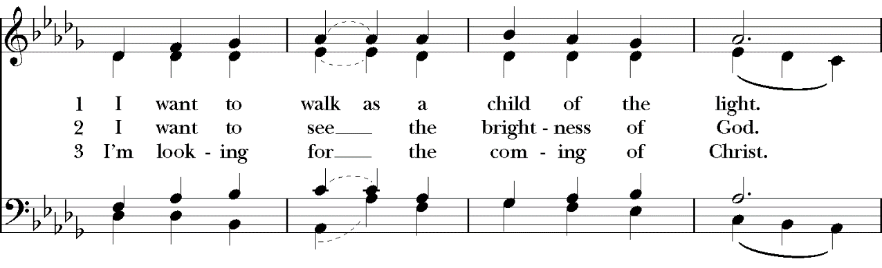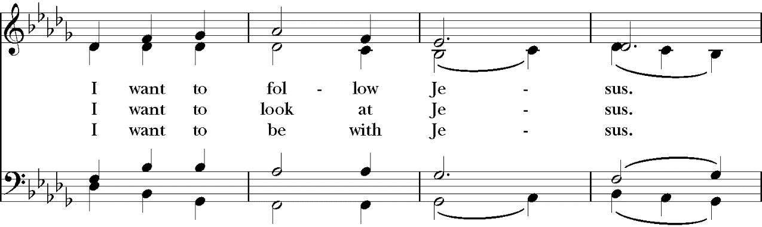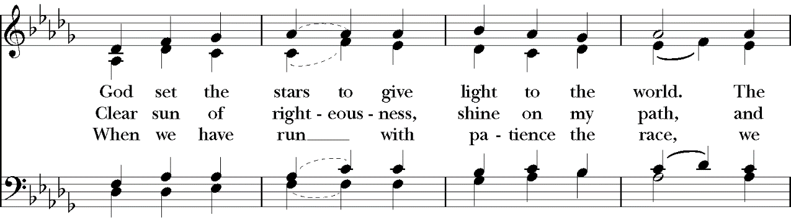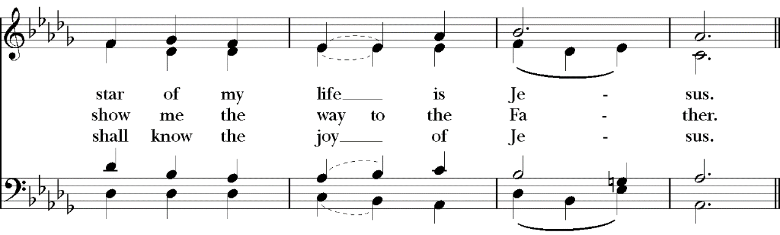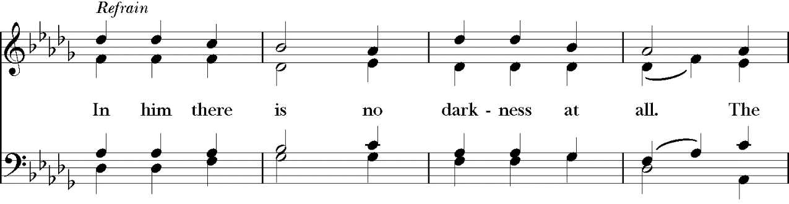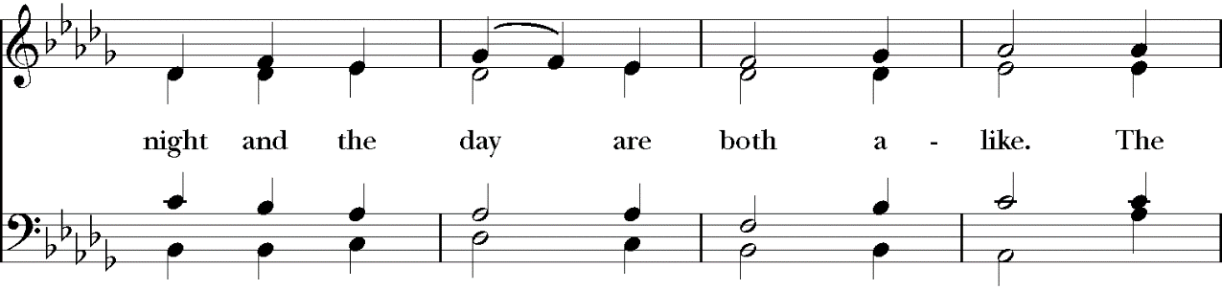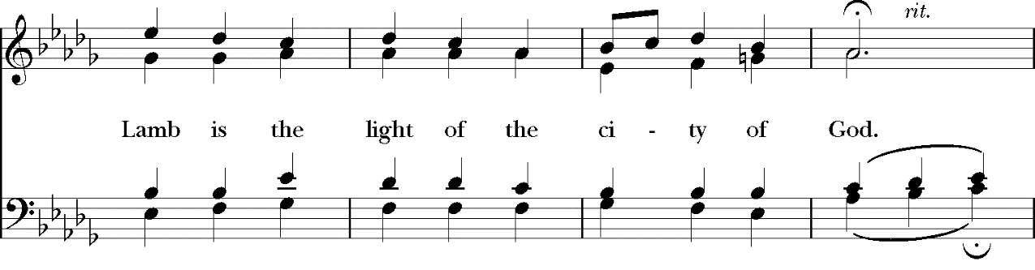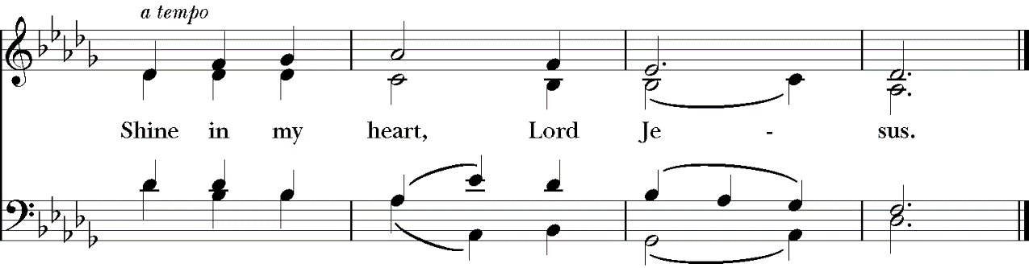

Words: Kathleen Thomerson (b. 1934)

Music: Houston, Kathleen Thomerson (b. 1934)

**The Great Thanksgiving**

*All remain standing.*

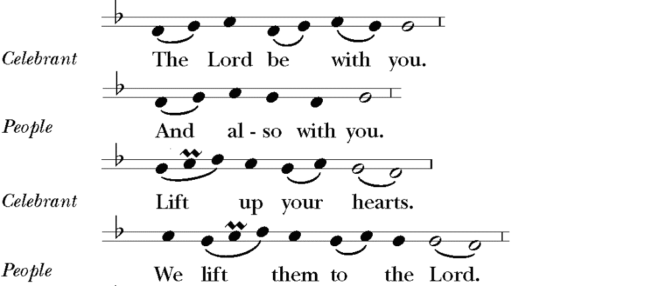

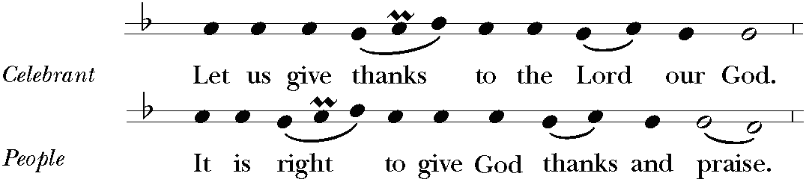

*Celebrant* It is right, and a good and joyful thing, always and everywhere to give thanks to you, Father Almighty, Creator of heaven and earth; because you sent your beloved Son to redeem us from sin and death, and to make us heirs in him of everlasting life; that when he shall come again in power and great triumph to judge the world, we may without shame or fear rejoice to behold his appearing. Therefore we praise you, joining our voices with Angels and Archangels and with all the company of heaven, who for ever sing this hymn to proclaim the glory of your Name:

*All sing “Holy, holy, holy” (Hymn #S 114)*



Music: From *Missa de Sancta Maria Magdalena*, Healey Willan (1880-1968)

Copyright: By permission of Oxford University Press.

*The people stand or kneel.*

*Celebrant*  We give thanks to you, O God, for the goodness and love which you have made known to us in creation; in the calling of Israel to be your people; in your Word spoken through the prophets; and above all in the Word made flesh, Jesus, your Son. For in these last days you sent him to be incarnate from the Virgin Mary, to be the Savior and Redeemer of the world. In him, you have delivered us from evil, and made us worthy to stand before you. In him, you have brought us out of error into truth, out of sin into righteousness, out of death into life.

On the night before he died for us, our Lord Jesus Christ took bread; and when he had given thanks to you, he broke it, and gave it to his disciples, and said, “Take, eat: This is my Body, which is given for you. Do this for the remembrance of me.”

After supper he took the cup of wine; and when he had given thanks, he gave it to them, and said, “Drink this, all of you: This is my Blood of the new Covenant, which is shed for you and for many for the forgiveness of sins. Whenever you drink it, do this for the remembrance of me.”

*Celebrant* And we offer our sacrifice of praise and thanksgiving to you, O Lord of all; presenting to you, from your creation, this bread and this wine.

We pray you, gracious God, to send your Holy Spirit upon these gifts that they may be the Sacrament of the Body of Christ and his Blood of the new Covenant. Unite X us to your Son in his sacrifice, that we may be acceptable through him, being sanctified by the Holy Spirit. In the fullness of time, put all things in subjection under your Christ, and bring us to that heavenly country where, with Mary, the Virgin Mother of God and all your saints, we may enter the everlasting heritage of your sons and daughters; through Jesus Christ our Lord, the firstborn of all creation, the head of the Church, and the author of our salvation.

By him, and with him, and in him, in the X unity of the Holy Spirit all honor and glory is yours, Almighty Father,

*Celebrant* And now, as our Savior Christ hath taught us, we are bold to say,

***All*** **Our Father, who art in heaven,**

**hallowed be thy Name,**

**thy kingdom come,**

**thy will be done,**

**on earth as it is in heaven.**

**Give us this day our daily bread.**

**And forgive us our trespasses,**

**as we forgive those who trespass against us.**

**And lead us not into temptation,**

**but deliver us from evil.**

**For thine is the kingdom, and the power, and the glory,**

**for ever and ever. Amen.**

**The Breaking of the Bread**

*The Celebrant breaks the consecrated bread. A period of silence is observed.*

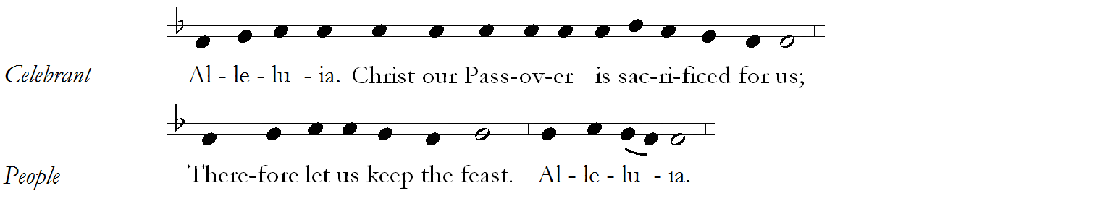

*All remain standing and sing “Lamb of God” (Hymn #S 158)*







Music: From *Missa de Sancta Maria Magdalena*, Healey Willan (1880-1968)

Copyright: By permission of Oxford University Press.

**Invitation to Holy Communion**

*The Celebrant invites the people to receive the Holy Communion saying this or some other invitation.*

*Celebrant* The Gifts of God for the people of God. [Take them in remembrance that Christ died for you, and feed on him in your hearts by faith with thanksgiving.]

*All baptized persons, including children, are full members of the Body of Christ and are invited to participate in every aspect of the service and receive the Holy Communion. Members of other Christian churches who are baptized are also invited to receive the Body and Blood of Christ. Persons who do not wish to receive Holy Communion are also invited to come forward with everyone else to receive a blessing (cross your arms over your chest to indicate that you want a blessing and not Holy Communion).*

**Anthem at the Communion**

*The choir sings* Jesus, so lowly *by Harold W. Friedell (1905-1958) during the ministration of Holy Communion.*

|  |  |
| --- | --- |
| Jesus, so lowly,  Child of the earth:  Christen me wholly,  Bring me new birth.  Jesus, so lonely,  Weary and sad;  Teach me that only  Love maketh glad. | Jesus, so broken,  Silent and pale;  Be this the token  Love will not fail.  Jesus, victorious,  Mighty and free;  Teach me how glorious  Death is to be. |

* Edith Williams (1899-?)

**Postcommunion Prayer**

*All kneel as you are able.*

*Celebrant* Let us pray.

*All* **Almighty and everliving God,**

**we thank you for feeding us with the spiritual food**

**of the most precious Body and Blood**

**of your Son our Savior Jesus Christ;**

**and for assuring us in these holy mysteries**

**that we are living members of the Body of your Son,**

**and heirs of your eternal kingdom.**

**And now, Father, send us out**

**to do the work you have given us to do,**

**to love and serve you**

**as faithful witnesses of Christ our Lord.**

**To him, to you, and to the Holy Spirit,**

**be honor and glory, now and for ever. Amen.**

**Blessing**

*Celebrant*  May Christ, the Son of God, be manifest in you, that your lives may be a light to the world; and the blessing of God Almighty, the Father, the Son, and the Holy Spirit, be among you, and remain with you always.

***All***  **Amen.**

**Processional Hymn (#135)**

*All remain standing and sing the hymn as the clergy, acolytes, and choir process from the sanctuary.*

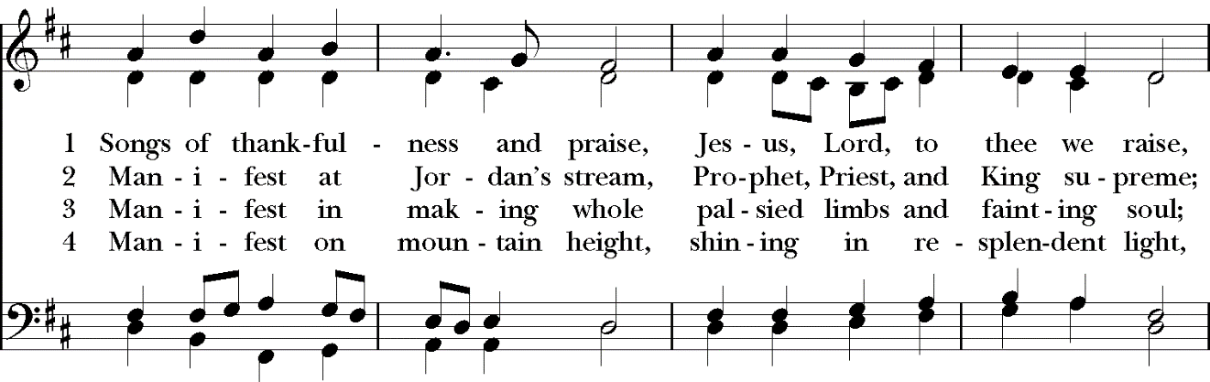

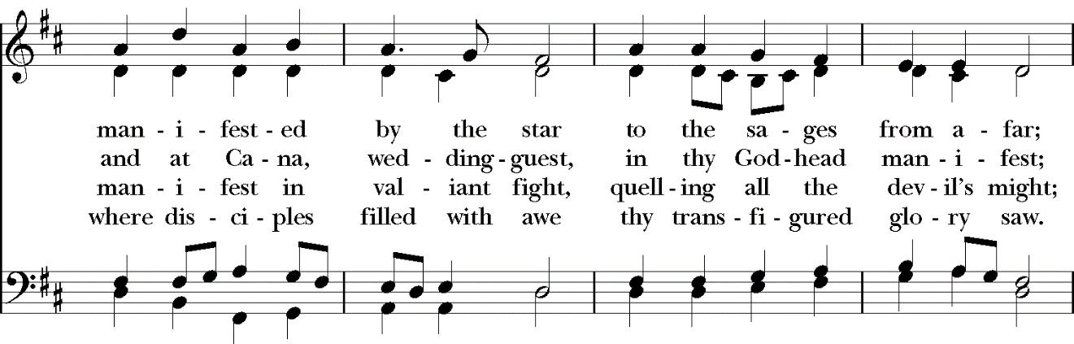

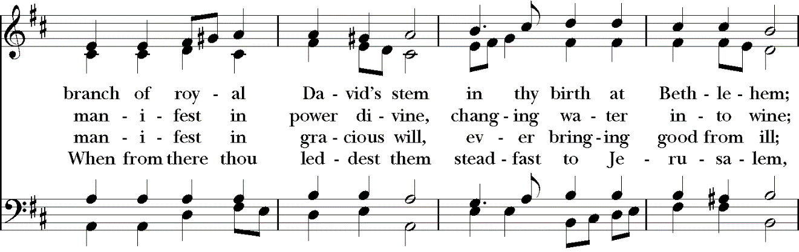

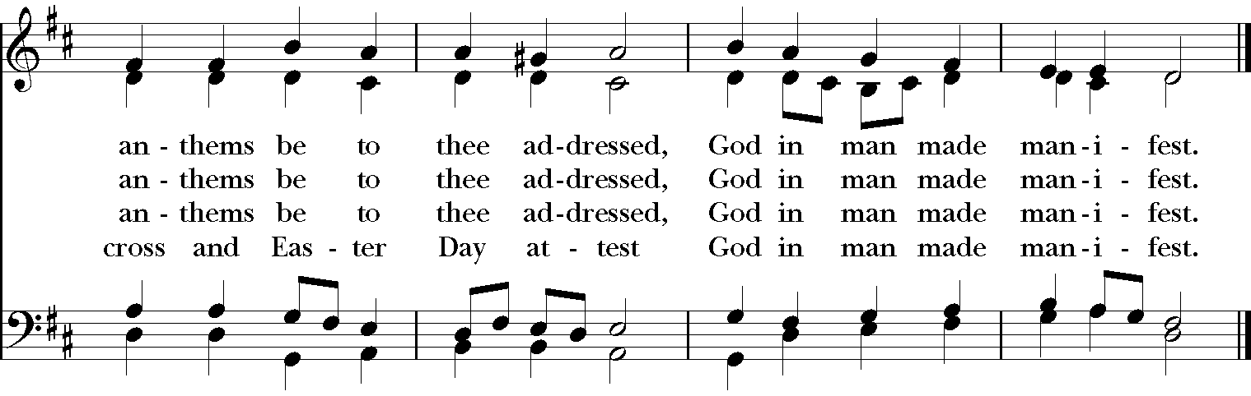

Words: Sts. 1-3, Christopher Wordsworth (1807-1885); st. 4, F. Bland Tucker (1895-1984)  
Music: *Salzburg*, melody Jakob Hintze (1622-1702); harm. Johann Sebastian Bach (1685-1750)

**dismissal**

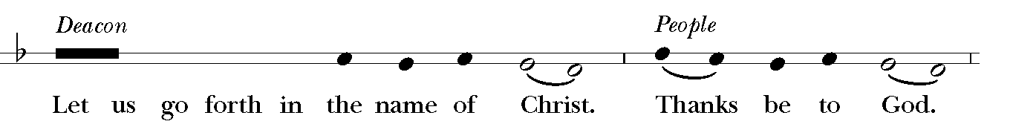

**Organ Voluntary**

*If you are staying in your pew for the Voluntary, please be courteous to those who are listening to the music by remaining quiet.*

Chorale-Prelude on “Christ, unser Herr, zum Jordan kam” (“Christ, our Lord, went to Jordan’s stream”), BWV 684, *by Johann Sebastian Bach (1685-1750).*

**Prayers for Healing at the Bolton Altar**

*Following the Eucharist every Sunday prayers for healing with the anointing of Holy Oil are offered by Deacon Chisara or Father Matt. Come to the altar and tell the priest or deacon what you want to pray for.*

***Scan this QR Code to join our Email List and catch up on everything that’s happening at Christ Church***

***Scan this QR Code to donate online.***

Christ church

### Episcopal/Anglican

### Clergy & Staff

The Reverend Matthew Hoxsie Mead*, Rector*

The Reverend Deacon Chisara Alimole

Mr. Jeffrey Hoffman*, Organist and Choirmaster*

Ms. Marie Main*, Parish Administrator*

Mr. Walter Roberts*, Verger and Sexton*

Mr. Ed Blue*, Sexton*

#### Wardens & Vestry

The Reverend Matthew Hoxsie Mead*, Rector*

Mr. Jeff Bodenmann, *Senior Warden*

Ms. Carol Ipsen, *Junior Warden*

Ms. Allison Bodenmann*, Treasurer*

Mr. John Fox, *Assistant Treasurer*

Ms. Jean Gruener, *Clerk*

Ms. Jennifer Hawks Bland Ms. Etta Gumbs

Mr. Andy Des Rault Mr. Jack Kraft

Mr. Stephen Dolan Mr. Robert Landis

Mr. John Fox Ms. Courtney McGrory

Ms. Barbara Zambelli

***The Holy Eucharist is celebrated on Sundays at 8 and 10 a.m.***

***Morning Prayer*** *is read on, Tuesdays at 10:30 a.m. on Zoom*

† A Parish of the Diocese of New York †

**Christ Church**  
The Parish of Christ the Redeemer

1415 Pelhamdale Avenue, Pelham, New York 10803

914.738.5515

914.712.0526, *fax*

www.christchurchpelham.org

***Christ Church Pelham is a Christian community in the Episcopal tradition.***

***As members of the Body of Christ, we are dedicated to spiritual growth***

***and committed to serving God through worship and***

***service to our community and the world.***