Christmas Eve

The Nativity of our Lord Jesus Christ

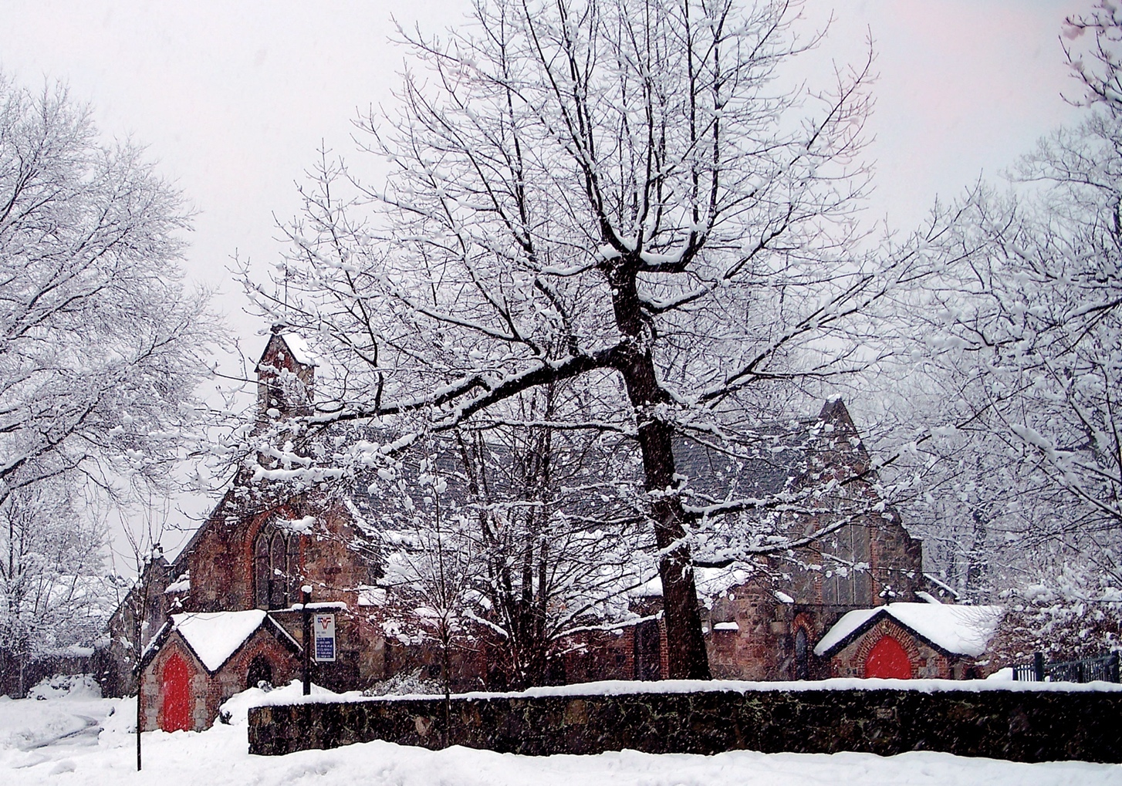

Family Holy Eucharist

4:00 pm

The Parish of Christ the Redeemer
Pelham Manor, New York
Welcome to Christ Church

The Parish of Christ the Redeemer (known as Christ Church) is the Episcopal Church in Pelham, New York. The Episcopal Church is part of the Anglican Communion which is made up of 85 million people in over 165 countries and is the third largest Christian denomination in the world. Christ Church was founded in 1843 and is the first house of worship in Pelham. This building was consecrated on September 15, 1843, the original church building was expanded in 1910, and the sanctuary was reconstructed in 1968 to allow for the current, more intimate worship space. If you want to take a guided tour of our church and grounds after today’s service, please speak to the rector, Father Matthew Mead. While you are here, please visit the Garden of the Resurrection, which is located behind the church and is one of the most beautiful hidden outdoor spaces in Pelham.

Our congregation draws primarily from Pelham, New Rochelle, Mount Vernon, and the Bronx, and includes people from diverse denominational and cultural backgrounds. Whether you are new to Christ Church or a long-time member, you are invited to pray in our sacred spaces, join in our services of worship, and take an active role in the life and leadership of the parish. We give thanks and praise to God for your presence with us this morning!

Children of all ages are always welcome in church. A great place for children to see, hear and participate is in the front pews of the church. Sunday School is offered during the academic year from September until June. Sunday School begins at 10:00 AM each Sunday (whenever the Pelham Schools are in session). After the children’s service and Sunday School activities, the children join the rest of the congregation for the Holy Communion.

The Episcopal Church teaches that all baptized persons, including children and Christians from any denomination, are full members of the Body of Christ and are invited to participate in every aspect of the service and receive Holy Communion. Persons who do not wish to receive Holy Communion are also invited to come forward with everyone else to receive a blessing.

If you believe God may be calling you to a new relationship with him through Jesus Christ we want to be of help. Whether you want to receive the Sacrament of Holy Baptism, receive the laying on of hands by the bishop in the sacramental rite of Confirmation, or transfer your membership from another church or denomination, joining Christ Church is easy, just speak to Father Matthew Mead, Deacon Chisara Alimole, or our Administrator, Ms. Marie Main. Next time you are online find and like us on Facebook!

If you need any assistance, please speak to one of our ushers. Restrooms are located in our Parish Hall which can be reached by walking to the right of the organ and down the hallway (follow the red carpet). Please turn your cell phones and other electronics off for the duration of the service.

About the Service

Christians began celebrating the birth of Jesus on December 25 near the beginning of the fourth century. By the beginning of the fifth century, a midnight celebration on Christmas Eve was held in Rome and spread throughout Western Europe. Christmas Masses soon became among the most beloved services of the year for Christians.

The gospels of Matthew and Luke both record the story of Christ’s birth. John’s gospel begins with a proclamation on the meaning of it.

The service is Rite II from the Book of Common Prayer 1979. Hymns are taken from the Hymnal 1982. All copyright music reprinted with permission under OneLicense.net Number A713125 for the exclusive use of Christ Church, Pelham. Unauthorized duplication is prohibited by law. This service is livestreamed and will be available on our website and YouTube channel.

Instrumental Prelude

Before the service begins, we offer instrumental selections played by our string quartet and organist. Please remain quiet once you are seated.

Three familiar Christmas carols arranged by Christina Harmon (b. 1944)

- Il est né le divin enfant (He is born, the Divine Christ-child)
- Coventry Carol (Lully, lullay, thou little tiny child)
- The First Nowell

10. Sinfonia (Pastorale) from Weinachtsoratorium (Christmas Oratorio), BWV 248 by Johann Sebastian Bach (1685-1750).

Entrance Carol
All stand and sing the carol.

1 O come, all ye faithful,
joyful and triumphant,
O come ye, O come ye to Bethlehem;
come, and behold him,
born the King of angels;
O come, let us adore him, (repeat x3)
Christ the Lord!

2 God of God,
Light of Light,
lo! he abhors not the Virgin’s womb;
very God, begotten not created
O come, let us adore him, (repeat x3)
Christ the Lord!

3 See how the shepherds,
summoned to his cradle,
leaving their flocks, draw nigh with lowly fear;
we too will thither
bend our joyful footsteps;
O come, let us adore him, (repeat x3)
Christ the Lord!

4 Child, for us sinners
poor and in the manger,
Fain we embrace thee, with awe and love;
who would not love thee,
loving us so dearly?
O come, let us adore him, (repeat x3)
Christ the Lord!

5 Sing, choirs of angels,
sing in exultation,
sing, all ye citizens of heaven above;
glory to God,
in the highest;
O come, let us adore him, (repeat x3)
Christ the Lord!

6 Yea, Lord, we greet thee,
born this happy morning;
Jesus, to thee be glory given;
Word of the Father,
now in flesh appearing;
O come, let us adore him, (repeat x3)
Christ the Lord!

Words: John Francis Wade (1711-1786); tr. Frederick Oakeley (1802-1880) and others
Music: Adeste fideles, present form of melody att. John Francis Wade (1711-1786); harm. The English Hymnal, 1906. Public domain.
Last verse arr. David Willcocks (1919-2015). Copyright © 1961 and 1987 by Oxford University Press.

Opening Acclamation & Collect for Purity
All remain standing.
Celebrant X Blessed be God: Father, Son, and Holy Spirit.
People And blessed be God’s kingdom, now and for ever. Amen.

Celebrant Almighty God, to you all hearts are open, all desires known, and from you no secrets are hid: Cleanse the thoughts of our hearts by the inspiration of your Holy Spirit, that we may perfectly love you, and worthily magnify your holy Name; through Christ our Lord.
All Amen.

Gloria in excelsis
All remain standing and sing the carol.

1 Angels we have heard on high,  singing sweetly through the night,  and the mountains in reply  echoing their brave delight.  Gloria in excelsis Deo.  Gloria in excelsis Deo.  2 Shepherds, why this jubilee?  Why these songs of happy cheer?  What great brightness did you see?  What glad tidings did you hear?  Gloria in excelsis Deo.  Gloria in excelsis Deo. | 3 Come to Bethlehem and see  him whose birth the angels sing;  come, adore on bended knee  Christ, the Lord, the newborn King.  Gloria in excelsis Deo.  Gloria in excelsis Deo.  4 See him in a manger laid  whom the angels praise above;  Mary, Joseph, lend your aid,  while we raise our hearts in love.  Gloria in excelsis Deo.  Gloria in excelsis Deo.

Words: French carol; tr. James Chadwick (1813-1882), alt.
Music: Gloria, French carol; arr. Edward Shippen Barnes (1887-1958) & Jeffrey Hoffman (b. 1970)

Collect of the Day
All remain standing.
Celebrant The Lord be with you
People And also with you.
Celebrant Let us pray.
O God, you make us glad by the yearly festival of the birth of your only Son Jesus Christ: Grant that we, who joyfully receive him as our Redeemer, may with sure confidence behold him when he comes to be our Judge; who lives and reigns with you and the Holy Spirit, one God, now and for ever.
All Amen.

First Lesson: Isaiah 9:2-3, 6-7
All are seated.
Reader A Reading from the Book of Isaiah.
The people who walked in darkness have seen a great light; those who lived in a land of deep darkness – on them light has shined. You have multiplied the nation, you have increased its joy; they rejoice before you as with joy at the harvest, as people exult when dividing plunder. For a child has been born for us, a son given to us; authority rests upon his shoulders; and he is named Wonderful Counselor, Mighty God, Everlasting Father, Prince of Peace. His authority shall grow continually, and there shall be endless peace for the throne of David and his kingdom. He will establish and uphold it with justice and with righteousness from this time onward and forevermore. The zeal of the LORD of hosts will do this.
The Word of the Lord.
People Thanks be to God.

Gradual Carol
All remain seated while the parish choir sings In the bleak midwinter by Harold Darke (1888-1976). The soloists are Jeanmarie Lally, soprano, and John Burke, tenor.

In the bleak mid-winter  Frosty wind made moan;  Earth stood hard as iron,  Water like a stone;  Snow had fallen, snow on snow,  Snow on snow,  In the bleak mid-winter  Long ago.  Our God, heaven cannot hold Him  Nor earth sustain,  Heaven and earth shall flee away  When He comes to reign:  In the bleak mid-winter  A stable-place sufficed  The Lord God Almighty —  Jesus Christ. | Enough for Him, whom cherubim  Worship night and day,  A breastful of milk  And a mangerful of hay;  Enough for Him, whom Angels  Fall down before,  The ox and ass and camel  Which adore.  What can I give Him,  Poor as I am? —  If I were a Shepherd  I would bring a lamb;  If I were a Wise Man  I would do my part, —  Yet what I can I give Him, —  Give my heart.
– Christina Rosetti (1830-1894)

Second Lesson: Titus 2:11-14
All remain seated.
Reader A Reading from the Letter of Paul to Titus.
For the grace of God has appeared, bringing salvation to all, training us to renounce impiety and worldly passions, and in the present age to live lives that are self-controlled, upright, and godly, while we wait for the blessed hope and the manifestation of the glory of our great God and Savior, Jesus Christ. He it is who gave himself for us that he might redeem us from all iniquity and purify for himself a people of his own who are zealous for good deeds.
The Word of the Lord.
People Thanks be to God.

Carol at the Sequence
All stand and sing the carol.

1 O little town of Bethlehem,
how still we see thee lie!
Above thy deep and dreamless sleep
the silent stars go by;
yet in thy dark streets shineth
the everlasting Light;
the hopes and fears of all the years
are met in thee tonight.

2 O morning stars, together
proclaim the holy birth!
and praises sing to God the King,
and peace to men on earth.
For Christ is born of Mary;
and gathered all above,
while mortals sleep, the angels keep
their watch of wondering love.

3 How silently, how silently,
the wondrous gift is given!
So God imparts to human hearts
the blessings of his heaven.
No ear may hear his coming,
but in this world of sin,
where meek souls will receive him, still
the dear Christ enters in.

4 Where children pure and happy
pray to the blessed Child,
where misery cries out to thee,
Son of the mother mild;
where charity stands watching
and faith holds wide the door,
the dark night wakes, the glory breaks,
and Christmas comes once more.

5 O holy Child of Bethlehem,
descend to us, we pray;
cast out our sin and enter in,
be born in us today.
We hear the Christmas angels
the great glad tidings tell;
O come to us, abide with us,
our Lord Emmanuel!

Words: Phillips Brooks (1835–1893)
Music: St. Louis, Lewis H. Redner (1831-1908)

The Holy Gospel: Luke 2:1-20
All remain standing for the Gospel.
Deacon X The Holy Gospel of our Lord Jesus Christ according to Luke.
People Glory to you, Lord Christ.
Deacon In those days a decree went out from Emperor Augustus that all the world should be registered. This was the first registration and was taken while Quirinius was governor of Syria. All went to their own towns to be registered. Joseph also went from the town of Nazareth in Galilee to Judea, to the city of David called Bethlehem, because he was descended from the house and family of David. He went to be registered with Mary, to whom he was engaged and who was expecting a child. While they were there, the time came for her to deliver her child. And she gave birth to her firstborn son and wrapped him in bands of cloth, and laid him in a manger, because there was no place for them in the inn. In that region there were shepherds living in the fields, keeping watch over their flock by night. Then an angel of the Lord stood before them, and the glory of the Lord shone around them, and they were terrified. But the angel said to them, “Do not be afraid; for see – I am bringing you good news of great joy for all the people: to you is born this day in the city of David a Savior, who is the Messiah, the Lord. This will be a sign for you: you will find a child wrapped in bands of cloth and lying in a manger.” And suddenly there was with the angel a multitude of the heavenly host, praising God and saying, “Glory to God in the highest heaven, and on earth peace among those whom he favors!” When the angels had left them and gone into heaven, the shepherds said to one another, “Let us go now to Bethlehem and see this thing that has taken place, which the Lord has made known to us.” So they went with haste and found Mary and Joseph, and the child lying in the manger. When they saw this, they made known what had been told them about this child; and all who heard it were amazed at what the shepherds told them. But Mary treasured all these words and pondered them in her heart. The shepherds returned, glorifying and praising God for all they had heard and seen, as it had been told them.
The Gospel of the Lord.
People Praise to you, Lord Christ.

The Sermon
All are seated for the sermon by the Rector, Father Matthew Mead.

The Nicene Creed
All stand and join in saying the Nicene Creed.
Celebrant We believe in one God,
All the Father, the Almighty,
maker of heaven and earth,
of all that is, seen and unseen.

We believe in one Lord, Jesus Christ,
the only Son of God,
eternally begotten of the Father,
God from God, Light from Light,
true God from true God,
begotten, not made,
of one Being with the Father.
Through him all things were made.
For us and for our salvation
he came down from heaven:
by the power of the Holy Spirit
he became incarnate from the Virgin Mary,
and was made man.
For our sake he was crucified under Pontius Pilate;
he suffered death and was buried.
On the third day he rose again
in accordance with the Scriptures;
he ascended into heaven
and is seated at the right hand of the Father.
He will come again in glory to judge the living and the dead,
and his kingdom will have no end.

We believe in the Holy Spirit, the Lord, the giver of life,
who proceeds from the Father and the Son.
With the Father and the Son he is worshiped and glorified.
He has spoken through the Prophets.
We believe in one holy catholic and apostolic Church.
We acknowledge one baptism for the forgiveness of sins.
We look for the resurrection of the dead,
and the life of the world to come. Amen.

The Prayers of the People
All remain standing. The reader and people pray responsively.
Reader In peace let us pray to the Lord.
For all people in their daily life and work;
People For our families, friends, and neighbors, and for those who are alone.

Reader For this community, the nation, and the world;
People For all who work for justice, freedom, and peace.

Reader For the just and proper use of your creation;
People For the victims of hunger, fear, injustice, and oppression.

Reader For all who are in danger, sorrow, or any kind of trouble;
People For those who minister to the sick, the friendless, and the needy.

Reader For the peace and unity of the Church of God;
People For all who proclaim the Gospel, and all who seek the Truth.

Reader For Michael. our Presiding Bishop, Andy, Allen, and Mary, our Bishops; for Matt, our Bishop elect, and for all bishops and other ministers;
People For all who serve God in the Church.

Reader For the special needs and concerns of this congregation.

Silence is observed. The People may add their own petitions.

The Celebrant adds a concluding prayer.
Celebrant Almighty God, you have poured upon us the new light of your incarnate Word: Grant that this light, enkindled in our hearts, may shine forth in our lives; through Jesus Christ our Lord, who lives and reigns with you, in the unity of the Holy Spirit, one God, now and for ever.
All Amen.
If you would like to offer a special prayer concern, please contact the Parish Office. Names remain on the list for one month; please let the office know if you would like someone listed for a longer time.

The Peace
All remain standing.
Rector The Peace of the Lord be always with you.
People And also with you.

Then the ministers and people greet one another in the name of the Lord.

Welcome & Announcements

All are seated for a welcome and announcements by the Rector, Father Matthew Mead.

Offertory Sentence
The Celebrant says the following or some other offertory sentence.
Celebrant Let us with gladness present the offerings and oblations of our life and labor to the Lord.
Carol at the Offertory

All remain seated as an offering is taken. The altar is prepared with the gifts of bread and wine. The parish choir sings the carol Jesus child by John Rutter (b. 1945).

Have you heard the story that they’re telling ’bout Bethlehem,

Have you heard the story of the Jesus child?

How he came from heaven and was born in a manger bed?

Mary was his virgin mother pure and mild.

Sing alleluia, brothers, sing alleluia, sisters,

Worship the Jesus child and praise his mother mild.

“Glory to God on high!” the angel hosts above are singing:

Listen to the story of the Jesus child.

Have you heard the story of the poor humble shepherd men,

Sitting on the hillside with their flocks at night?

Suddenly the angel tells them “Hurry to Bethlehem;

Go and find the Jesus child, the world’s new light.”

Sing alleluia, brothers, etc.

Jesus child, lying at Bethlehem,

Sleeping safe at Mary’s knee,

Save my soul and bring me to paradise,

Let me join the angels singing glory to thee.

Sing alleluia, brothers, etc.

Have you heard the story of the kings from the Orient,

Following the star that’s shining over his head?

Offering their precious gifts of gold, myrrh, and frankincense,

Kneeling with the ox and ass before his bed?

Sing alleluia, brothers, etc.

Brothers, let us celebrate the birth of the Jesus child,

Sisters, come and welcome him, the newborn King;

Praise the Lord who sent him down from heaven at Christmastime;

Young and old and rich and poor, his praises sing.

Sing alleluia, brothers, etc.

– John Rutter (b. 1945)

Congregational Carol at the Offertory
All stand and sing the carol as the offering is brought to the altar and blessed.

1 Hark! the herald angels sing
glory to the newborn King!
Peace on earth and mercy mild,
God and sinners reconciled!
Joyful, all ye nations, rise,
join the triumph of the skies;
with the angelic host proclaim
Christ is born in Bethlehem!
Hark! the herald angels sing
glory to the newborn King!

2 Christ, by highest heaven adored;
Christ, the everlasting Lord;
late in time behold him come,
offspring of the Virgin’s womb.
Veiled in flesh the Godhead see;
hail the incarnate Deity.
Pleased as man with us to dwell;
Jesus, our Emmanuel!
Hark! the herald angels sing
glory to the newborn King!

3 Hail, the heaven-born Prince of Peace!
Hail, the Sun of Righteousness!
Light and life to all he brings,
Risen with healing in his wings;
Mild he lays his glory by,
born that we no more may die,
born to raise the sons of earth,
born to give them second birth.
Hark! the herald angels sing
glory to the newborn King!

Words: Charles Wesley (1707-1788), alt.
Music: Mendelssohn, Felix Mendelssohn (1809-1847); adapt. William H. Cummings (1831-1915), arr. David Willcocks (1919-2015)
Published in The English Hymnal, 1906; public domain. David Willcocks arrangement (verse 3 descant and organ part), copyright © 1961 by
Oxford University Press.

The Great Thanksgiving
All remain standing.
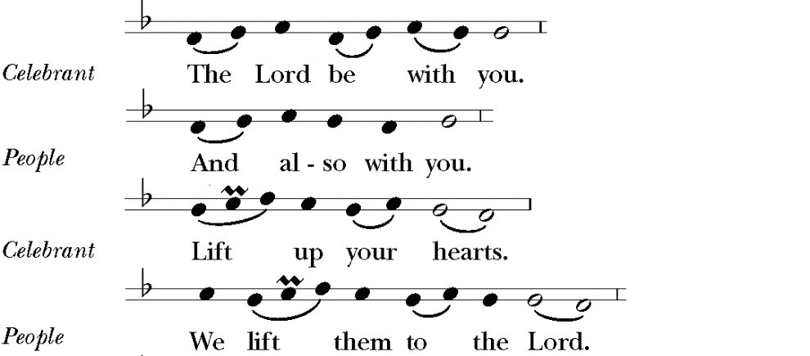
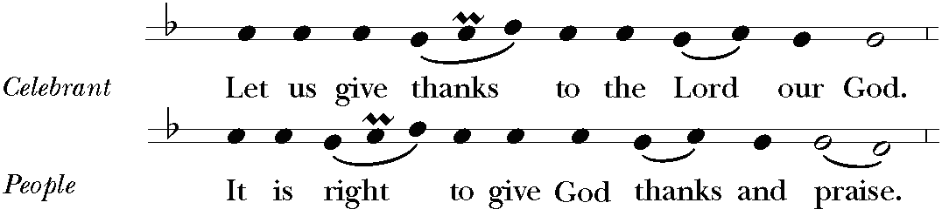

Celebrant It is right, and a good and joyful thing, always and everywhere to give thanks to you, Father Almighty, Creator of heaven and earth; because you gave Jesus Christ, your only Son, to be born for us; who, by the mighty power of the Holy Spirit, was made perfect Man of the flesh of the Virgin Mary his mother; so that we might be delivered from the bondage of sin, and receive power to become your children. Therefore we praise you, joining our voices with Angels and Archangels and with all the company of heaven, who for ever sing this hymn to proclaim the glory of your Name:

All remain standing and sing “Holy, holy, holy”.
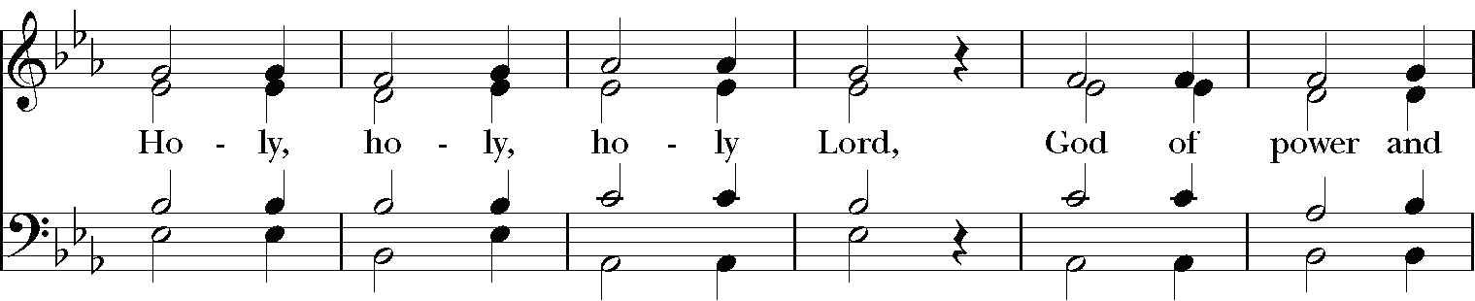
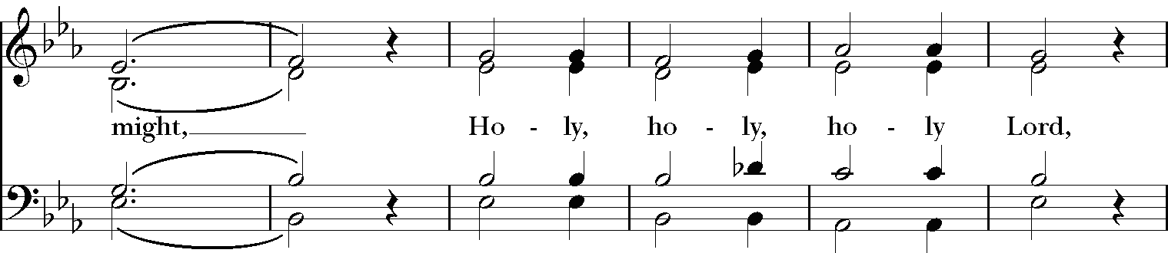
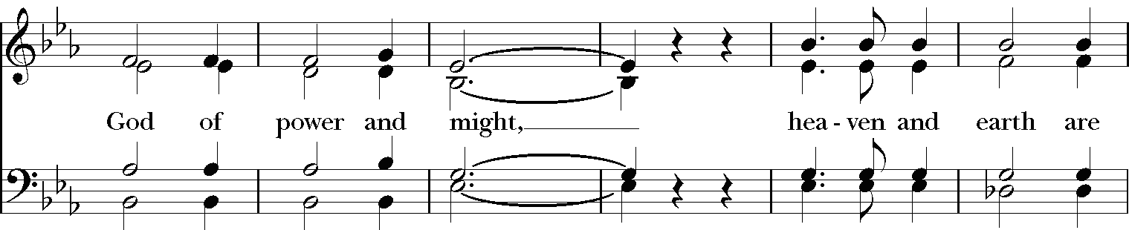
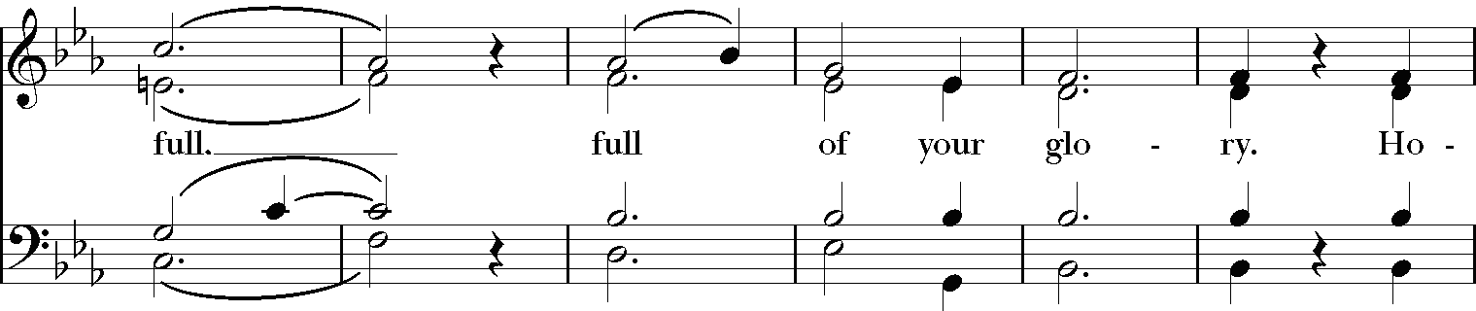
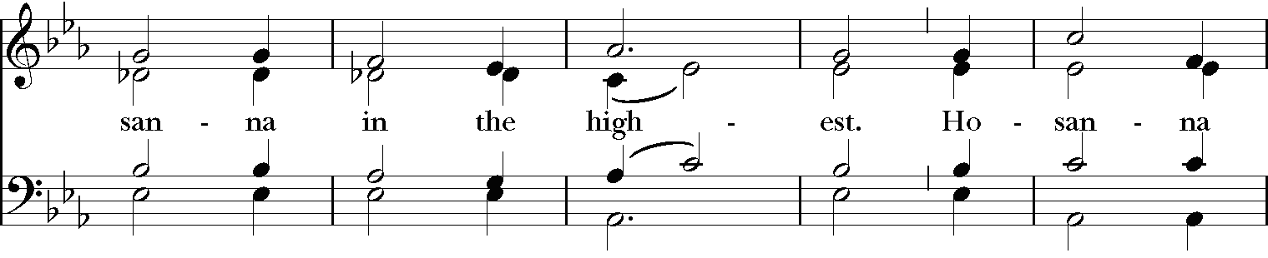
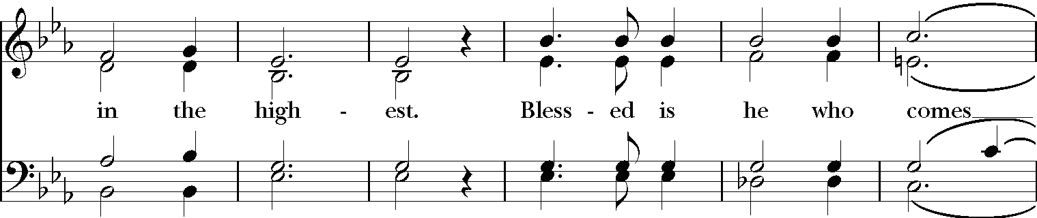
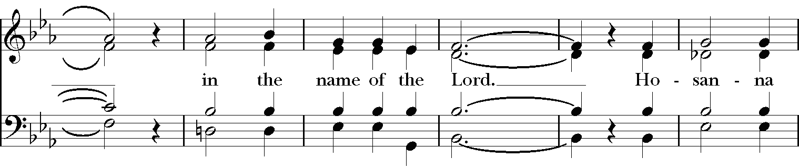
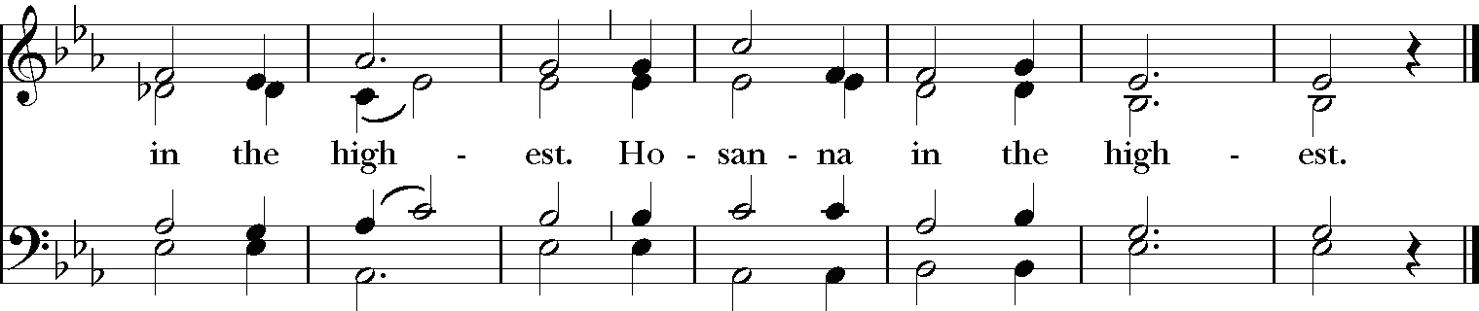
Music: From Deutsche Messe, Franz Peter Schubert (1797–1828); arr. Richard Proulx (b. 1937)
Copyright: Adaptation copyright © 1985, G.I.A. Publications, Inc.

The people kneel or stand.
Celebrant We give thanks to you, O God, for the goodness and love which you have made known to us in creation; in the calling of Israel to be your people; in your Word spoken through the prophets; and above all in the Word made flesh, Jesus, your Son. For in these last days you sent him to be incarnate from the Virgin Mary, to be the Savior and Redeemer of the world. In him, you have delivered us from evil, and made us worthy to stand before you. In him, you have brought us out of error into truth, out of sin into righteousness, out of death into life.

On the night before he died for us, our Lord Jesus Christ took bread; and when he had given thanks to you, he broke it, and gave it to his disciples, and said, “Take, eat: This is my Body, which is given for you. Do this for the remembrance of me.”

After supper he took the cup of wine; and when he had given thanks, he gave it to them, and said, “Drink this, all of you: This is my Blood of the new Covenant, which is shed for you and for many for the forgiveness of sins. Whenever you drink it, do this for the remembrance of me.”

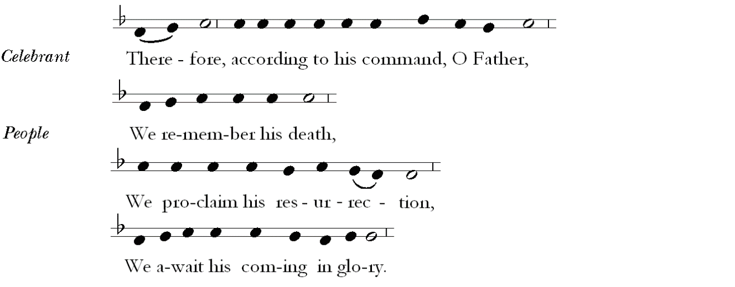

Celebrant And we offer our sacrifice of praise and thanksgiving to you, O Lord of all; presenting to you, from your creation, this bread and this wine.

We pray you, gracious God, to send your Holy Spirit upon these gifts that they may be the Sacrament of the Body of Christ and his Blood of the new Covenant. Unite X us to your Son in his sacrifice, that we may be acceptable through him, being sanctified by the Holy Spirit. In the fullness of time, put all things in subjection under your Christ, and bring us to that heavenly country where, with Mary, the Virgin Mother of God and all your saints, we may enter the everlasting heritage of your sons and daughters; through Jesus Christ our Lord, the firstborn of all creation, the head of the Church, and the author of our salvation.

By him, and with him, and in him, in the X unity of the Holy Spirit all honor and glory is yours, Almighty Father,
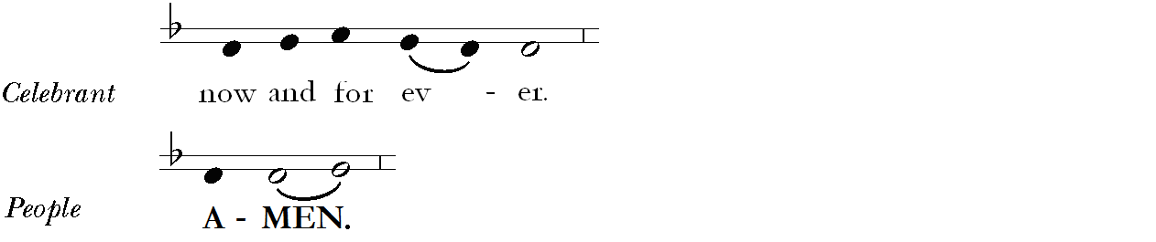

Celebrant And now, as our Savior Christ hath taught us, we are bold to say,
All Our Father, who art in heaven,
hallowed be thy Name,
thy kingdom come,
thy will be done,
on earth as it is in heaven.
Give us this day our daily bread.
And forgive us our trespasses,
as we forgive those who trespass against us.
And lead us not into temptation,
but deliver us from evil.
For thine is the kingdom, and the power, and the glory,
for ever and ever. Amen.

The Breaking of the Bread
The Celebrant breaks the consecrated bread. A period of silence is observed.
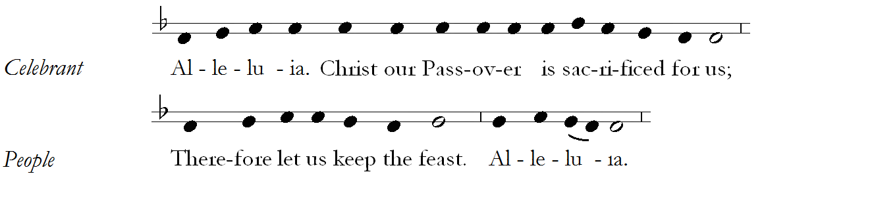

All sing “Jesus, Lamb of God”
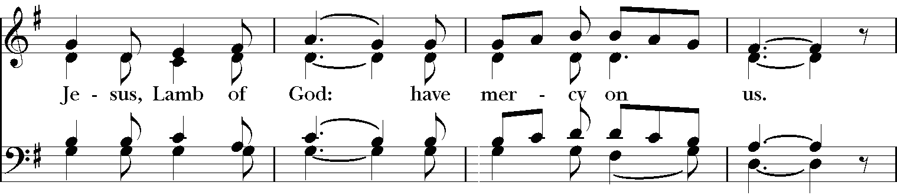
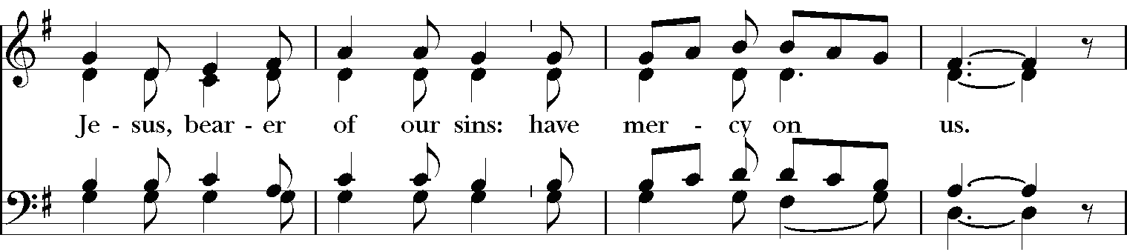
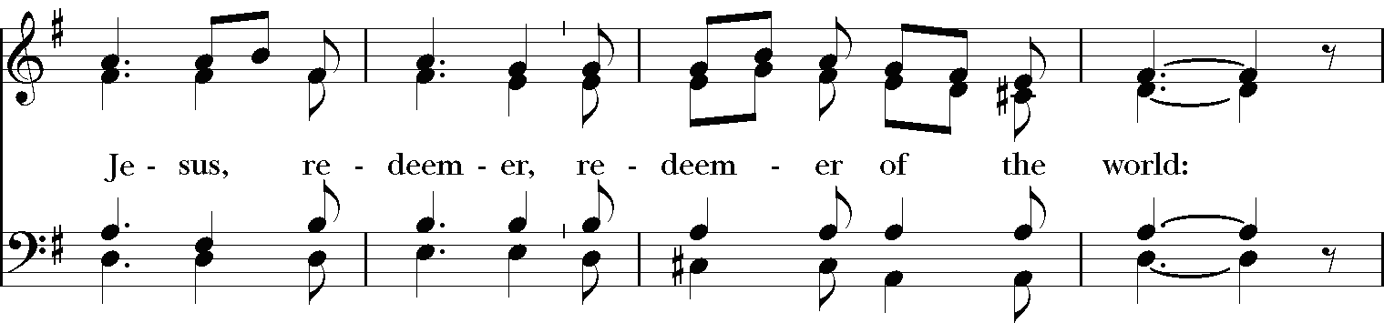
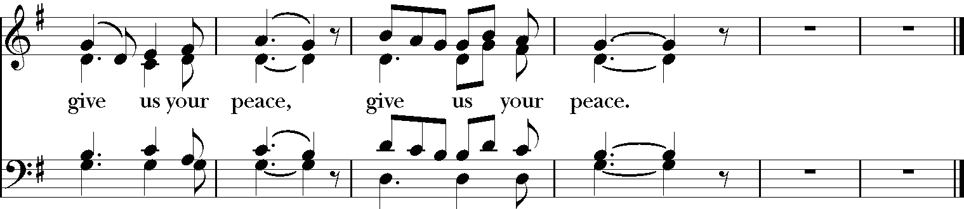
Music: From Deutsche Messe; Franz Peter Schubert (1797–1828); arr. Richard Proulx (b. 1937)
Copyright: Adaptation copyright © 1985, G.I.A. Publications, Inc

Invitation to Holy Communion
The Celebrant invites the people to receive the Holy Communion.
Celebrant The Gifts of God for the people of God. Take them in remembrance that Christ died for you, and feed on him in your hearts by faith with thanksgiving.

All baptized persons, including children, are full members of the Body of Christ and are invited to participate in every aspect of the service and receive the Holy Communion. Members of other Christian churches who are baptized are also invited to receive the Body and Blood of Christ. Persons who do not wish to receive Holy Communion are also invited to come forward with everyone else to receive a blessing (cross your arms over your chest to indicate that you want a blessing and not Holy Communion).

Carols at the Communion
During the ministration of Holy Communion, the string quartet and organist play Es ist ein Ros’ entsprungen (Lo, how a rose e’er blooming), a 16th century German carol, arranged by Ralph C. Schultz (b. 1932) and Michael Prætorius (1571-1621).

During the ministration of Holy Communion the choir sings the carol Infant holy, infant lowly, a traditional Polish carol, arranged by David Willcocks (1919-2015).

Infant holy, Infant lowly, for His bed a cattle stall;
Oxen lowing, little knowing, Christ the Babe is Lord of all.
Swift are winging angels singing, noels ringing, tidings bringing:
Christ the Babe is Lord of all.

Flocks were sleeping, shepherds keeping vigil till the morning new
Saw the glory, heard the story, tidings of a Gospel true.
Thus rejoicing, free from sorrow, praises voicing, greet the morrow:
Christ the Babe was born for you.

– translated from the original Polish by Edith M. Reed (1885-1933)

During the ministration of Communion the choir sings the carol What sweeter music by John Rutter (b. 1945).

What sweeter music can we bring,  Than a carol, for to sing  The birth of this our heavenly King?  Awake the voice! Awake the string!  Heart, ear, and eye, and everything.  Awake! the while the active finger  Runs division with the singer.  Dark and dull night, fly hence away,  And give the honor to this day,  That sees December turned to May.  Why does the chilling Winter’s morn  Smile, like a field beset with corn?  Or smell, like to a meadow newly shorn,  Thus, on the sudden?  Come and see  The cause, why things thus fragrant be:  ’Tis He is born, whose quickening birth  Gives life and luster, public mirth,  To heaven, and the under-earth. | We see Him come, and know Him ours,  Who, with His sunshine, and His showers,  Turns all the patient ground to flowers.  The darling of the world is come,  And fit it is, we find a room  To welcome Him. The nobler part  Of all the house here, is the heart,  Which we will give Him; and bequeath  This holly, and this ivy wreath,  To do Him honor; who’s our King,  And Lord of all this reveling.  – Robert Herrick (1591-1674), adapted

Postcommunion Prayer
After Communion all stand and join in the final prayer.
Celebrant Let us pray.
All Almighty and everliving God,
we thank you for feeding us with the spiritual food
of the most precious Body and Blood
of your Son our Savior Jesus Christ;
and for assuring us in these holy mysteries
that we are living members of the Body of your Son,
and heirs of your eternal kingdom.
And now, Father, send us out
to do the work you have given us to do,
to love and serve you
as faithful witnesses of Christ our Lord.
To him, to you, and to the Holy Spirit,
be honor and glory, now and for ever. Amen.

Procession to the Crèche
The People remain standing as the Celebrant bids the Procession.
Celebrant Father Almighty, you have caused this holy night to shine with the brightness of the true Light, your Son our Lord Jesus Christ: Grant that we, who have known the mystery of that Light on earth, may also enjoy him perfectly in heaven; where with you and the Holy Spirit he lives and reigns, one God, in glory everlasting.
People Amen.

Celebrant Let us go now to Bethlehem and see this thing that has taken place, which the Lord has made known to us.
People So they went with haste and found Mary and Joseph, and the child lying in the manger.

Procession to the Crèche
The Ministers process to the Crèche during the carol.

1 The first Nowell the angel did say
Was to certain poor shepherds in fields as they lay;
In fields where they lay, keeping their sheep,
On a cold winter’s night that was so deep:
Nowell, Nowell, Nowell, Nowell,
Born is the King of Israel.

2 They lookéd up and saw a star
Shining in the east beyond them far;
And to the earth it gave great light,
And so it continued both day and night.
Refrain

3 And by the light of that same star
Three wise men came from country far;
To seek for a king was their intent,
And to follow the star wherever it went.
Refrain

4 This star drew nigh to the northwest,
O’er Bethlehem it took its rest,
And there it did both stop and stay
Right over the place where Jesus lay.
Refrain

5 Then entered in those wise men three
Full reverently upon their knee,
And offered there in his presence
Their gold, and myrrh, and frankincense.
Refrain

6 Then let us all with one accord
Sing praises to our heavenly Lord;
That hath made heaven and earth of nought,
And with his blood mankind hath bought:
Refrain

Words: English carol, 18th cent.
Music: The First Nowell, English carol, 17th cent.; arr. by David Willcocks (1919-2015). Copyright © 1961 by Oxford University Press.
Prayers at the Crèche
The procession stops at the Crèche.
Celebrant The Word was made flesh and dwelt among us;
People And we beheld his glory.

Celebrant Let us pray.
Almighty God, you have given your only-begotten Son to take our nature upon him, and to be born of a pure virgin: Grant that we, who have been born again and made your children by adoption and grace, may daily be renewed by your Holy Spirit; through our Lord Jesus Christ, to whom with you and the same Spirit be honor and glory, now and for ever.
People Amen.

Carol at the Crèche
All sing the carol as incense is offered.

1 Silent night, holy night,
all is calm, all is bright
round yon virgin mother and child.
Holy infant, so tender and mild,
sleep in heavenly peace.

2 Silent night, holy night,
shepherds quake at the sight,
glories stream from heaven afar,
heavenly hosts sing alleluia;
Christ, the Savior, is born!

3 Silent night, holy night,
Son of God, love’s pure light
radiant beams from thy holy face,
with the dawn of redeeming grace,
Jesus, Lord, at thy birth.

Words: Joseph Mohr (1792-1848); tr. John Freeman Young (1820-1885)
Music: Stille Nacht, melody Franz Xaver Gruber (1787-1863); harm. Carl H. Reinecke (1824-1910) and Jeffrey Hoffman (b.1970).

Blessing at the Crèche
Celebrant The glory of the Lord has been revealed:
People And all flesh shall see the salvation of our God.

Celebrant May Almighty God, who sent his Son to take our nature upon him, bless you in this holy season, scatter the darkness of sin, and brighten your heart with the light of his holiness; May God, who sent his angels to proclaim the glad news of the Savior’s birth, fill you with joy, and make you heralds of the Gospel; May God, who in the Word made flesh joined heaven to earth and earth to heaven, give you his peace and favor; And the blessing of God Almighty, the Father, the Son, and the Holy Spirit, be upon you and remain with you now and always.
People Amen.

Processional Hymn
All sing the hymn as the ministers process to the back of the church.

1 Joy to the world! the Lord is come:
let earth receive her King;
let every heart prepare him room,
and heaven and nature sing.

2 Joy to the world! the Savior reigns;
let us our songs employ,
while fields and floods, rocks, hills and plains,
repeat the sounding joy.

3 No more let sins and sorrows grow,
nor thorns infest the ground;
he comes to make his blessings flow
far as the curse is found.

4 He rules the world with truth and grace,
and makes the nations prove
the glories of his righteousness,
and wonders of his love.

Words: Isaac Watts (1674-1748), alt.;
Music: Antioch, George Frideric Handel (1685-1759); adapt. and arr. Lowell Mason (1792-1872), descant by John Rutter (b. 1945).
Copyright © 1987 by Oxford University Press.

Dismissal
All remain standing for the dismissal.
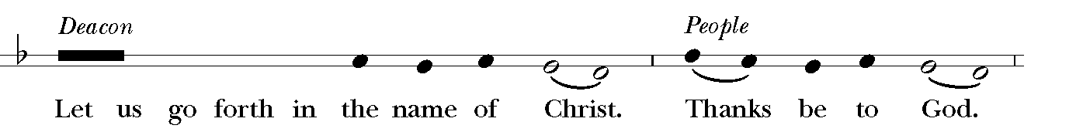

Instrumental Voluntary

12. Pifa (Pastoral symphony) from Messiah by George Frideric Handel (1685-1759).

Merry Christmas
&
Happy New Year
The Christmas Decorations and Special Music have been given to the Glory of God and in Memory of:

Mauri Richberg
James D. Greenhalgh
John and Dorothy Greenhalgh
LeRoy and Virginia Hepburn
Gail Grover Bensinger
Ronald Sauey
Ivan & Esmie Reece
Andrew Shenkman
Rufus Scroggins
Emma Bailey
Rita Ganpat
Xandra Schultz

George & Marie Landis
John G. Main
Julia Jean Hoffman
Mary Caroline Paul
Benjamin & Nora Spickler
Loved ones of the Weild Family
Meredith Fox
Lynn Mosca
Jack Hennigan
Jerry Baumgardner
Brad McKee
Carol Cole
Mairi Staples

We remember all those who rejoice with us,
but upon another shore, and in a greater light, that multitude which no man can number, whose hope was in the Word made flesh, and with whom, in this Lord Jesus,
we are forever one.”

Flowers in Thanksgiving for

Abigail, Robert & Elizabeth Young, Christopher & Matt Landis
For Family Past & Present, G&G Frizz being with us, The Cole Family, Organists, the Wiggins & Scroggins Family

ACOLYTE GUILD
Walter Roberts, Verger

Kathryn Alexander, Will Alexander, Angela Lore-Barone, Harris Bland, Court Jones, Vickie Brundage-Kish, Riley McGrory, Liam Mead, Nicholas Mead, Aeden Pearl, Sandra Rivera,

LECTORS AND EUCHARISTIC MINISTERS
Walter Roberts, Verger
Russell Avolio, Angela Lore-Barone, Allison Bodenmann, Rosemary Carver, Curtis Chase, Jane Cooke, Justice Diakite, Patrice Fitzpatrick, Alban Graham, Cherrie Greenhalgh, Carol Ipsen, Erik Ipsen, Melo Jones, James Kenworthy, Missy Kisob, Jack Kraft, Gavin Leckie, Alison Pearl, Sandra Rivera, Melissa Roddy, Tom Salvatore, Steve Swanson, Jim Young, Barbara Zambelli

ALTAR GUILD
Jackie Kraft & Paige Lavengood, Co-Chairs

Angela Lore-Barone, Ellen Dierking, Vicki Brundage-Kish, Janet Kornfeld, Marilyn Leone, Sandra Rivera, Walter Roberts, Janet Salvatore, Lavinia Scroggins, Annette Wiggins

MORNING PRAYER
Father Matthew H. Mead, Rector
Kari Black, Carol Ipsen

FLOWER GUILD
Patrice Fitzpatrick, Chairperson

Angela Lore-Barone, Allison Bodenmann, Alice Dean, Marie Dumas, Charlette Finch., Etta Gumbs, Emily Kane, Katherine Kenworthy, Colette Phipps, Janet Salvatore, Cherie Sigward

USHERS
Jean Gruener & Tom Salvatore, Co-Chairs

Daniel Avolio, Angela Lore-Barone, Bob Boyer, Vicki Brundage-Kish, Lorraine Collins, Andy Des Rault, Justice Diakite, Evan Felicetti, Patrice Fitzpatrick, John Fox, Alban Graham, Joe Goonan, Jean Gruener, Carol Ipsen, Erik Ipsen, Katherine & James Kenworthy, Jack Kraft, Marilyn Leone, Marie Main, Tom Salvatore, Patricia Sweeney.

THE PARISH CHOIR
Jeffrey Hoffman, organist & director of music (Choirmaster)

Kim de Beaumont, Allison Bodenmann, Jeff Bodenmann, John Burke*, Curtis Chase, Simon Cram*, Jann Degnan*, Denise Devoni-Liburd, Dennis Doran, Cheryl Greenhalgh, John Hastings, Margo Hastings, Mboti (Missy) Kisob, Jeanmarie Lally*, Jim Young, and Margaret Young

*denotes professional chorister

Instrumentalists
Claire Smith Bermingham, violin Marina Fragoulis, violin
Denise Cridge, viola Carolyn Jeselsohn, violoncello
Jeffrey Hoffman, organ

All copyright music reprinted with permission under OneLicense.net Number A713125 for the exclusive use of Christ Church, Pelham. Unauthorized duplication is prohibited by law.

Christ church

Episcopal/Anglican

Clergy & Staff

The Reverend Matthew Hoxsie Mead, Rector
The Reverend Deacon Chisara Alimole
Mr. Jeffrey Hoffman, Organist and Choirmaster
Ms. Marie Main, Parish Administrator
Mr. Walter Roberts, Verger and Sexton
Mr. Ed Blue, Sexton

Christ Church
The Parish of Christ the Redeemer
1415 Pelhamdale Avenue, Pelham, New York 10803│914.738.5515, fax 914.712.0526│www.christchurchpelham.org

